Sent out: Thursday 24th April | Due back: Thursday 15th May
Task:
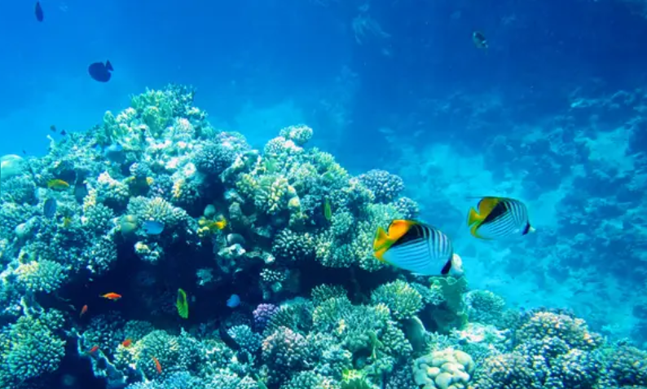 Why do oceans matter?

Do some research about oceans and why they are important. You could do this as a broad overview or as a focused project looking at one aspect of oceans such as: what is unique about one particular ocean; what is the impact of global warming on the oceans; what wildlife is there is there in one particular ocean; what is the impact of pollution on the oceans.

As always, you can present this learning in any way that you like. Some ideas include: a double page spread, a poster, an informative piece of writing, a small model or a piece of artwork.

A reminder that your brain builder should not take more than a double page in your book.

Sent out: Thursday 24th April | Due back: Thursday 15th May
Task:
Why do oceans matter?

Do some research about oceans and why they are important. You could do this as a broad overview or as a focused project looking at one aspect of oceans such as: what is unique about one particular ocean; what is the impact of global warming on the oceans; what wildlife is there is there in one particular ocean; what is the impact of pollution on the oceans.

As always, you can present this learning in any way that you like. Some ideas include: a double page spread, a poster, an informative piece of writing, a small model or a piece of artwork.

A reminder that your brain builder should not take more than a double page in your book.

