ow – blow the snow 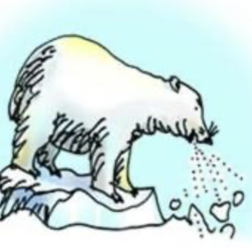 | Day 1 | Day 2 | Day 3 | Day 4 | Day 5
snow
show
slow
low
grow
mow
blow

