Sent out: Thursday 25th September | Due back: Thursday 16th October
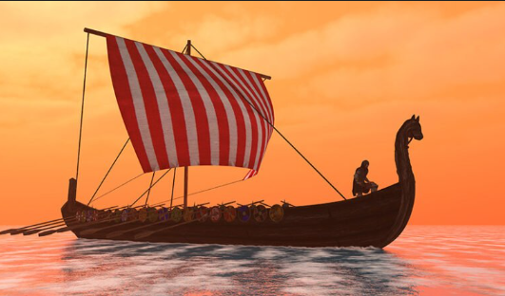 Task: Vikings – Raiders, Traders or something else?

Do some research about the Vikings. You could do this as a broad overview or as a focused project looking at one aspect of Viking life such as: how they lived, which countries they come from and went to or Sutton Hoo.

As always, you can present this learning in any way that you like. Some ideas include: a double page spread, a poster, an informative piece of writing, writing from the point of view of a Viking such as a diary, a small model or a piece of artwork.

A reminder that your brain builder should not take more than a double page in your book.

Sent out: Thursday 25th September | Due back: Thursday 16th October
Task: Vikings – Raiders, Traders or something else?

Do some research about the Vikings. You could do this as a broad overview or as a focused project looking at one aspect of Viking life such as: how they lived, which countries they come from and went to or Sutton Hoo.

As always, you can present this learning in any way that you like. Some ideas include: a double page spread, a poster, an informative piece of writing, writing from the point of view of a Viking such as a diary, a small model or a piece of artwork.

A reminder that your brain builder should not take more than a double page in your book.

