ee–  what can you see?  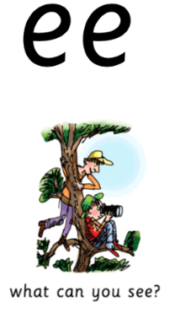 | Day 1 | Day 2 | Day 3 | Day 4 | Day 5
feet
meet
three
bee
sheep
teeth
see
queen

