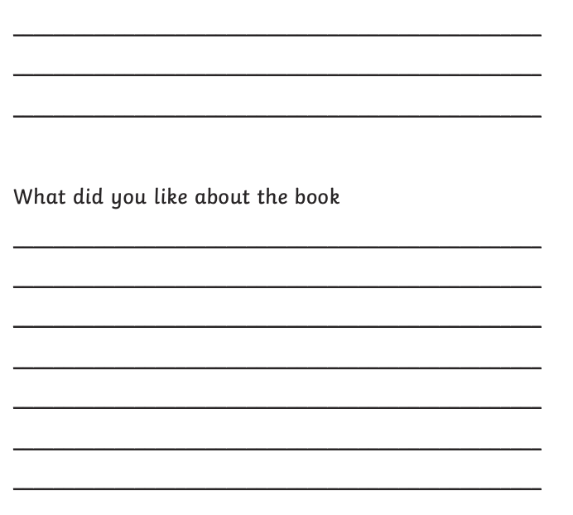
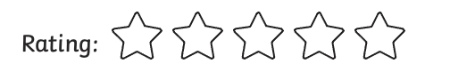
Book title: _____________________________________

Who are the main characters?
____________________________________________________
____________________________________________________
Where is the book set?
____________________________________________________
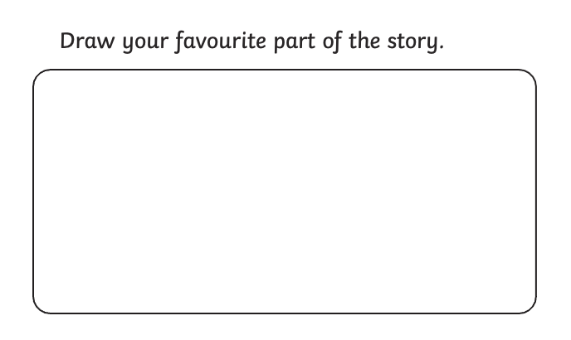
____________________________________________________
What is the book about?
____________________________________________________
____________________________________________________
____________________________________________________
____________________________________________________
____________________________________________________
____________________________________________________




