 | Look, Say, Cover, Write, Check | Look, Say, Cover, Write, Check | Look, Say, Cover, Write, Check | Look, Say, Cover, Write, Check
wreck 
write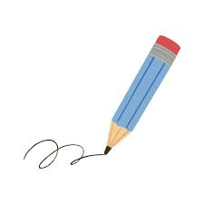
wrist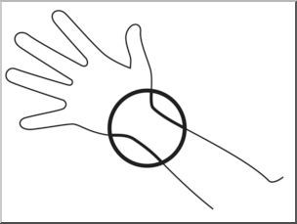
wrestle

wreath
wrong
wren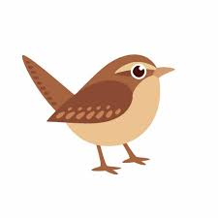
wrapping 

Now have a go at choosing 3 spelling words and write each in a sentence.
_____________________________________________________________________
_____________________________________________________________________
_____________________________________________________________________
_____________________________________________________________________
_____________________________________________________________________
_____________________________________________________________________

