Sent out: Thursday 23rd April | Due back: Thursday 14th May
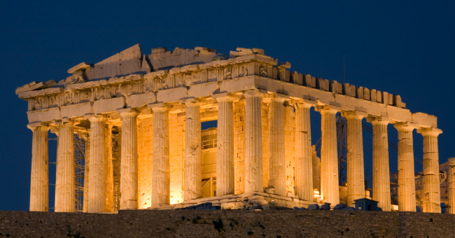 Task: What is the legacy of the Ancient Greek civilisation?

Do some research about the Ancient Greeks. You could do this as a broad overview or as a focused project looking at one aspect of Ancient Greek life such as: how they lived, the Greek Gods or myths.

As always, you can present this learning in any way that you like. Some ideas include: a double page spread, a poster, an informative piece of writing, writing from the point of view of an Ancient Greek such as a diary, a small model or a piece of artwork.

A reminder that your brain builder should not take more than a double page in your book.

Sent out: Thursday 23rd April | Due back: Thursday 14th May
Task: What is the legacy of the Ancient Greek civilisation?

Do some research about the Ancient Greeks. You could do this as a broad overview or as a focused project looking at one aspect of Ancient Greek life such as: how they lived, the Greek Gods or myths.

As always, you can present this learning in any way that you like. Some ideas include: a double page spread, a poster, an informative piece of writing, writing from the point of view of an Ancient Greek such as a diary, a small model or a piece of artwork.

A reminder that your brain builder should not take more than a double page in your book.

Sent out: Thursday 23rd April | Due back: Thursday 14th May
Task: What is the legacy of the Ancient Greek civilisation?

Do some research about the Ancient Greeks. You could do this as a broad overview or as a focused project looking at one aspect of Ancient Greek life such as: how they lived, the Greek Gods or myths.

As always, you can present this learning in any way that you like. Some ideas include: a double page spread, a poster, an informative piece of writing, writing from the point of view of an Ancient Greek such as a diary, a small model or a piece of artwork.

A reminder that your brain builder should not take more than a double page in your book.

