Sent out: Thursday 11th June | Due back: Thursday 2nd July
Task:
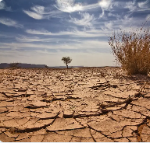 Would you like to live in the desert?

Do some research about deserts and consider whether you would like to live in one. You could do this as a broad overview or as a focused project looking at one aspect of deserts such as: what are the physical features of a desert; what can live in the desert or where you can find deserts in the world.

As always, you can present this learning in any way that you like. Some ideas include: a double page spread, a poster, an informative piece of writing, a small model or a piece of artwork.

A reminder that your brain builder should not take more than a double page in your book.

Sent out: Thursday 11th June | Due back: Thursday 2nd July
Task:
Would you like to live in the desert?

Do some research about deserts and consider whether you would like to live in one. You could do this as a broad overview or as a focused project looking at one aspect of deserts such as: what are the physical features of a desert; what can live in the desert or where you can find deserts in the world.

As always, you can present this learning in any way that you like. Some ideas include: a double page spread, a poster, an informative piece of writing, a small model or a piece of artwork.

A reminder that your brain builder should not take more than a double page in your book.

