Week 4, Writing Tasks
18.05.20

This week we thought the children might like to practise letter writing.
Key learning : how a letter should be set out, its’ structure and the appropriate content/language depending on the intended recipient and the purpose of the letter (eg: to inform, thank, or persuade).
Children could write an informal letter to their friends, relatives, or a member of staff at St Michaels. They could write their letter to an imaginary character from a story they have been reading, e.g. Willy Wonka or Charlie Bucket. Perhaps they could write a letter to somebody in the local community or someone nationally who has inspired them, they could write a letter of thanks to an NHS or care worker that they know, or somebody who has helped them in some way. Take their lead.
Here are some resources that could help along the way. If you have plenty of time, encourage children to focus on quality rather than quantity. Aim to spend some time looking at existing letters and how they are set out, followed by a planning stage of writing a draft, moving on to an improving/editing session and finally writing up in neat. Some templates are provided but there are also lots of other nice bordered pages that can be found online too.

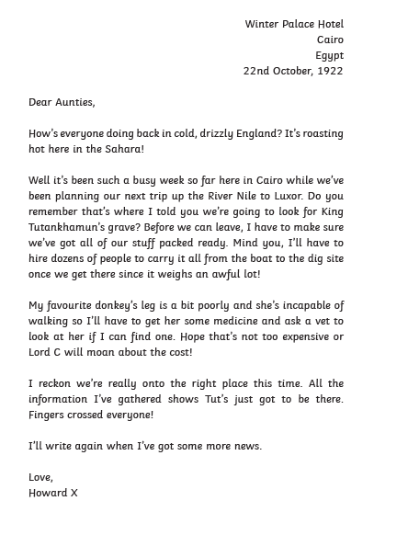
Example letter…
