February 2nd 2021

Children’s Mental Health Week
Dear Parents/Carers,
As many of you will be aware, Children’s Mental Health Week is taking part across the country on 1st-7th February 2021. The theme this year is ‘Express Yourself’. We will be taking part in this and teachers will have posted PSHE activities on their remote learning platforms and pages to support our children’s mental health.
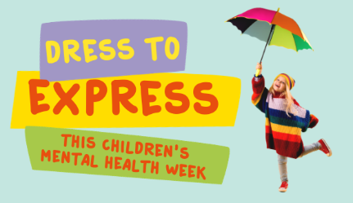
Expressing yourself is how you find creative ways to explore and convey your feelings to others, through art, drama, dress, costume, poetry, writing and dance.

As part of our focus, we would like to invite our children to send pictures to school, showing how they have chosen to ‘dress to express’ themselves this week. Alternatively, you may wish to share a piece of individual or collaborative artwork. Poems are always valued – the choices for how they wish to express themselves are infinite.
Please send pictures to:
office@stmichaelce.co.uk
The plan is for the school to create a photo slide show, accompanied by the Bill Wither’s classic ’Lovely Day’ single, to celebrate our children’s wealth of creativity.
Hopefully, the children will recall this uplifting and hopeful tune, as the opening music for many of our celebration assemblies in school.
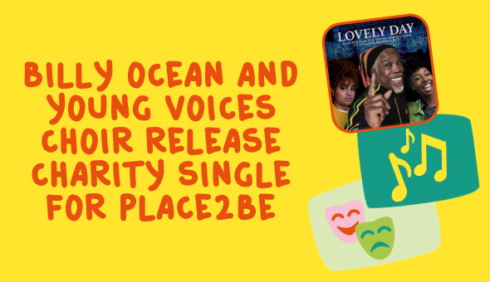
To coincide with Children’s Mental Health Week 2021, pop icon Billy Ocean has teamed up with the Young Voices Choir to release a new recording of this classic single‘.The single is available to download now via iTunes or Amazon.

All the UK profits from the song will go to Place2Be’s work supporting children and young people’s mental health during these challenging times.
Some of our more adventurous families may wish to share a video clip to show case a dance routine, accompanied by the single.
So, let’s seize this opportunity to support children’s mental health across the nation and lift all our spirits in the process.
More information for parents and carers, including further activities to enjoy at home, can be found by clicking on the link below:
https://www.childrensmentalhealthweek.org.uk/parents-and-carers/
Oak National Academy have teamed up with the charity Place2B, to create a free assembly featuring pupils and well known-faces discussing the theme of ‘Express Yourself’.
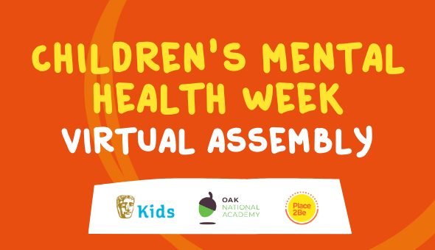

If you would like to watch this assembly with your child, please follow the link below.
https://www.childrensmentalhealthweek.org.uk/news/watch-our-children-s-mental-health-week-assembly-with-bafta-kids-and-oak-national-academy/
We are all looking forward to receiving photos and/or video clips of the children expressing their unique selves.

Warmest wishes
L Anderton and the staff team.

