Place 4 coloured pieces of paper (blue, red, yellow and green) on each of the 4 walls of the room and now try the following…
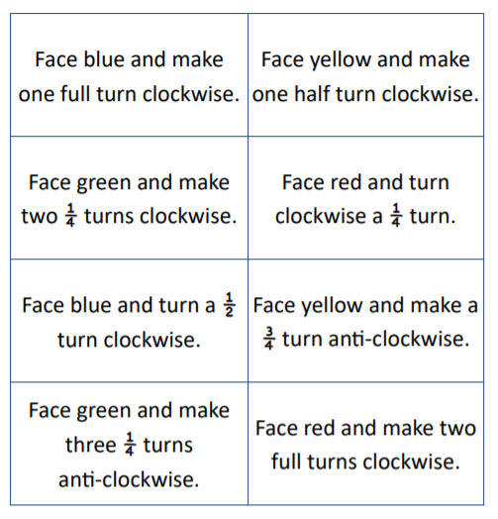

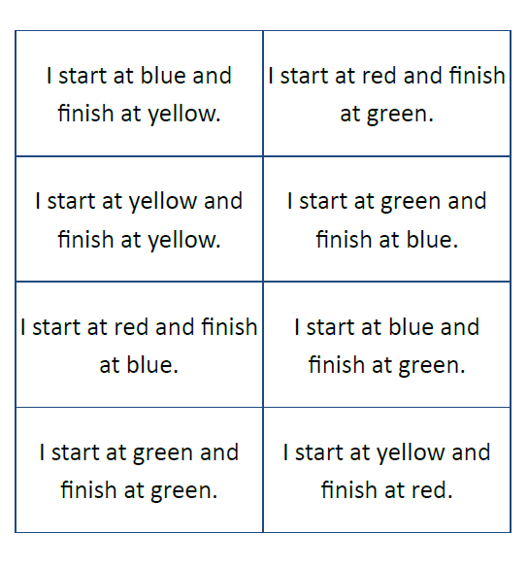
Partner A reads the card aloud, partner B describes the turn and the direction.
