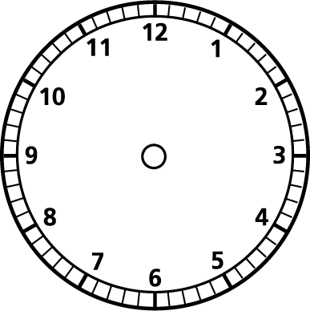

**Finish time = 15:35**

**Programme lasted for 2hrs 15 minutes.**

**When did it start?**

**Start = 4:15**

**Movie is 1hour 15 minutes**

**Start = 10:55**

**Movie is 1hr 35 minutes**

**Start = 18:47**

**Documentary is 2hrs 12 minutes**

**Start = 12:20.**

**Cartoon is 25 minutes long**

**Start = 7:35**

**Programme lasts for 50 minutes**