8.10.20
Autumnal nature walk
Autumn is on its way. We can feel it with slightly cooler temperatures, a little bit more breeze in the air, a dampness where lots of spiders suddenly appear. We can smell it with ripe fruits and fresher air. We can hear it with geese honking as they fly. We can see it in the start of the amazing colour changes in the trees and we can taste it with the ripe fruits. Autumn attacks all of our senses.
This week we want you to go on an autumnal walk and enjoy everything this season has to offer. Whether you head to the woods, local parks or fields use your five senses to describe what autumn feels like to you. Why don’t you collect some conquers, fallen leaves, acorns, cones and maybe even a pumpkin!! These findings will create our autumnal display in our classroom so take photos and have fun!!
Below is a table for you to complete to ensure you are engaging with your senses and encourage you to be more ambitious with your vocabulary (if you have one, use a thesaurus).
House points will be rewarded to those that can put findings from table into super sentences!!

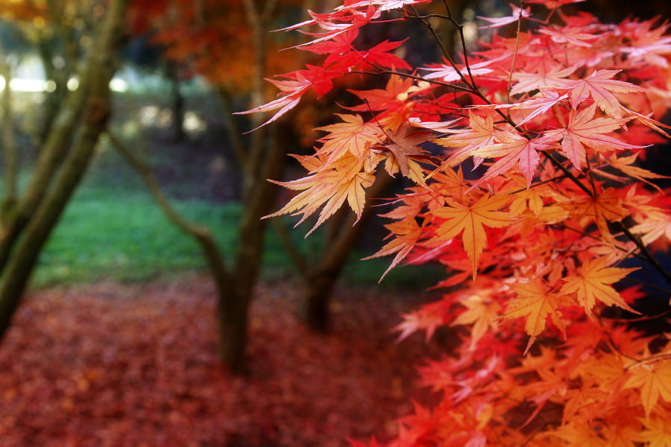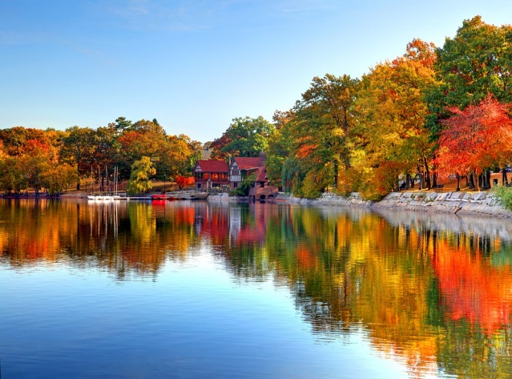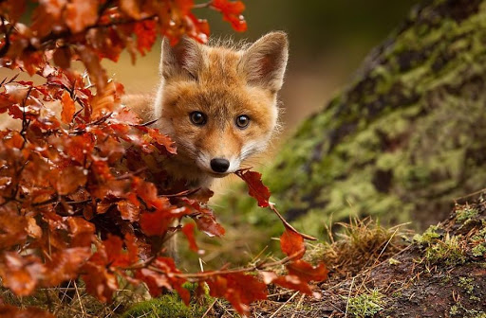

Touch | Taste | Smell | Hear | Sight
smooth | Ripe fruits | damp | Birds quietly singing | Tall thin trees

