January 8th 2021

Dear Children,

Firstly, I would like to say a huge thank you to you all for the commendable way in which you have responded to and approached this latest, national lockdown. Mr Johnson, our Prime Minister, has clearly needed to make some very difficult decisions to keep us all as safe as possible; sadly, this included closing schools and asking children to continue their learning from home. This places a huge responsibility on schools and parents, but most importantly the pupils themselves- you!
In his previous address, to the children of all ages attending school, Mr Williamson, acknowledged the role the children of this country played in maintaining the morale and positive ethos of the nation. You have a vital part to play, making sure your parents working at home and in those in key worker positions ‘on the front line’ are supported as much as possible, in their work.
Adults at home are aware of the learning objectives for each class, but they will need some help. Please be patient. Many of you will be able to follow the timetable of tasks and links independently, while others may need some guidance from their grown –ups. Should you have a younger sibling struggling with their school work, please offer to help; just as you would in school. All the class teachers have established a way for you to share your work with them and for you to receive feedback. Similarly, teachers are keeping a very close eye to ensure all children in their class are completing the tasks set. Teachers are rewarding house points and awards will be given, once we are back in school, to acknowledge and congratulate you on consistently following the 6Rs while working from home. We are also asking parents to let us know the children who have demonstrated 1 or more of the 6Rs during this lockdown period; this will include attitudes to learning, but also how you have stepped up to help your families during this difficult time.

We are all in this together and you must never underestimate your contribution at present, how committed your teachers and government are to supporting your continued learning at home and most importantly- how proud we are of you all.
Our new stained glass window, designed by Anna-Sofia Fox(now at Charter’s) and year 6.
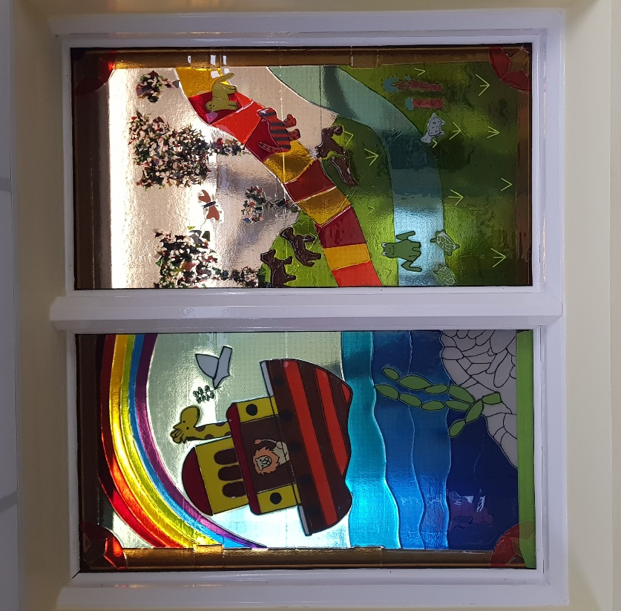

The window, located in the reception area, was installed just before Christmas and will add to the warm and welcoming feeling we like to extend to all visitors to our school.
Depicting the story of Noah’s Ark, was installed just before Christmas and is the perfect reminder to us all of the importance of the 6Rs, during challenging times.
Take care everyone. Stay safe and I look forward to ‘speaking’ to you all very soon.
Warmest wishes
Mrs Anderton

