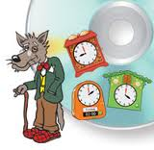
Telling the time
Using a ruler show me the times underneath the clock. Remember the small hand shows the hour and the big hand shows the minutes.
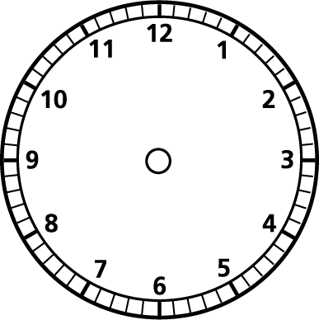

4 o’clock 2 o’clock

9 o’clock 7 o’clock

3 o’clock 12 o’clock
Telling the time
Using a ruler show me the times underneath the clock. Remember the small hand shows the hour and the big hand shows the minutes.

Half past 2 Half past 8

Half past 10 Half past 6

Half past 1 Half past 12

