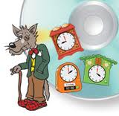
Telling the time
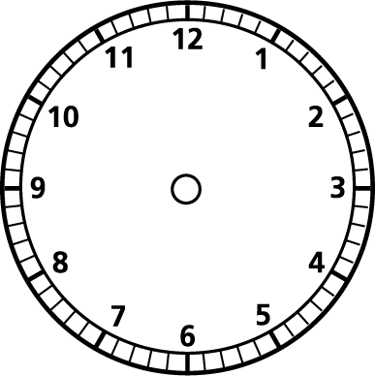
- Show me quarter past 2 on the analogue and digital clock.

- Show me quarter past 8 on the analogue and digital clock.

- Show me quarter to 5 on the analogue and digital clock.

- Show me quarter to 12 on the analogue and digital clock.

- Show me quarter past 3 on the analogue and digital clock.

6)Show me quarter to 9 on the analogue and digital clock.

