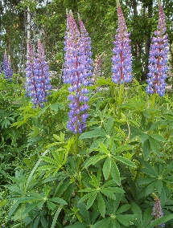
Making the World a More Beautiful Place
Dear Children,
I hope you have enjoyed the story of Miss Rumphius.
The lupin seeds have taken longer than expected to arrive, so it is important you plant these quickly and follow the instructions, to give them the best chance of germinating. Ask your grown -ups to help.
As we may be a little late in getting started with our lupin growing, some children will receive Nigella seeds to scatter. I am assured by Mr Anderton that these do not need to be started off indoors and can be planted directly into the ground. They will of course still need to be watered!
You will be able to identify the seeds you receive. Look for an ‘L’ or a ‘N’ on your envelope.
Instructions for Growing Lupin Seedlings
- Soak seeds in a saucer of water overnight.
- Fill a recyclable container with compost( an egg box is perfect).
- Plant seeds to a depth of 0.5cm.
- Water carefully- do not soak.
- Place on a windowsill. The seeds need warmth to germinate.
- You should see shoots in a week.
- When seedlings are about 10cm, plant where you wish them to bloom.
- Mr Anderton has sown some seeds and plans to transfer these to the school planters.
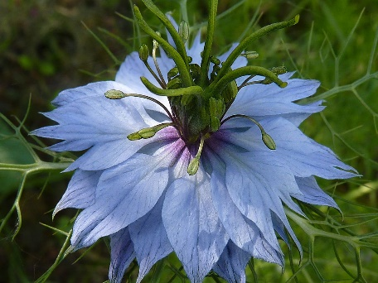
- Keep the soil damp. Be careful not to overwater.
Good luck!
Please share your successes with your class teachers.
Happy growing.
My love and best wishes to you and your families.
Mrs Anderton
Nigella (Love in a Mist)

