Maths Home Learning
Summer 1, Week 2 - 27.4.20

Suggested key areas of learning for year 2 this week:
Measuring capacity and volume (2-week module)
- To be able to read the temperature in degree Celsius on a thermometer
- To be able to take and read the temperature in degree Celsius
(you could look at daily weather reports – we know you may not have a thermometer at home!)
- To understand the concept of litres
- To estimate and measure in litres
- To solve word problems that involve litres
- To understand the concept of millilitres
- To be able to compare and order millilitres and litres
- To solve word problems about capacity and volume
(This could be co-operated into any baking or cooking you do too!)
Key Words
- Temperature
- Thermometer
- Unit of measure
- Degrees Celsius °C
- heat hot cold
- more than, less than, one litre, volume,
- capacity, estimate, measure

Feel free to use resources provided across this week, you may choose to take one area for each day, with a recap on Friday or if this feels like too much pick and choose areas of learning and spend longer on areas found difficult. Please do not feel that your child has to complete every single resource provided, in many cases there is a range of difficulty so you may prefer to choose the most suitable.
You may want to source your own materials in addition to or instead of the ones we have provided to meet the needs of your child. Take a look at websites such as Twinkl or TES for ideas.
To keep things light you may want to start your maths session with a short fun practical starter activity e.g. a game relating to times tables, using money and giving change, hit the button, naming and describing shapes, counting songs, splat the number square (see our links page for ideas), measuring or weighing objects found in the house, looking at the calendar, naming days and months, reading the time.

Fill in the missing blanks using words in the red boxes.
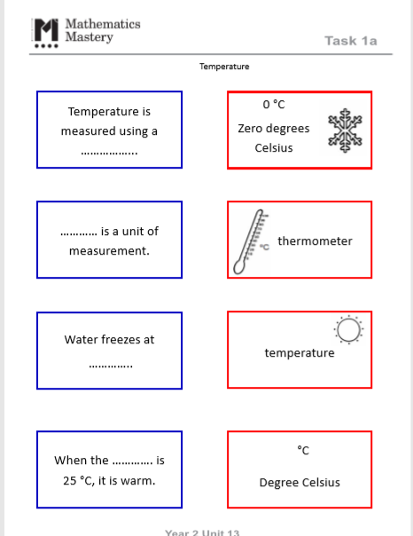

Walt - read temperatures in degree Celsius
Walt – solve word problems that involve degree Celsius
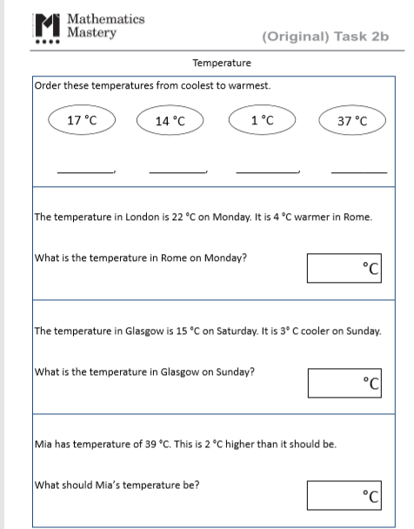
Walt – understand the concept of capacity and volume.
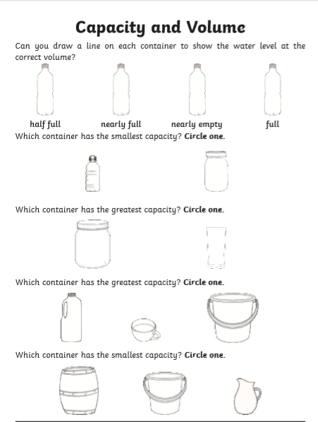

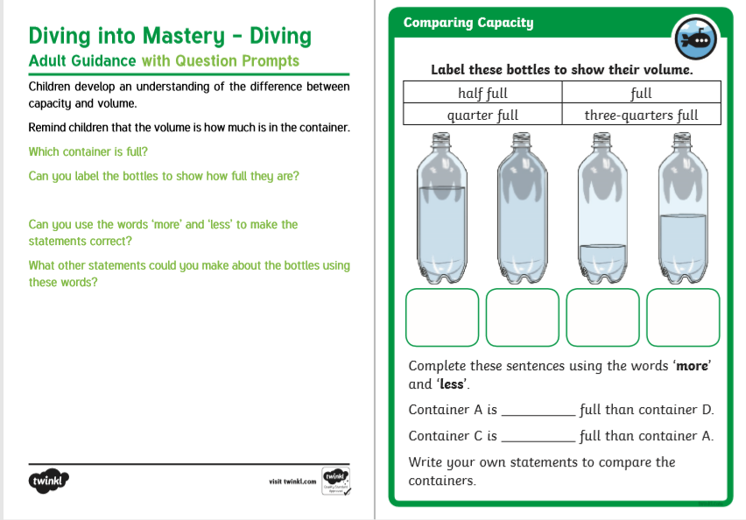
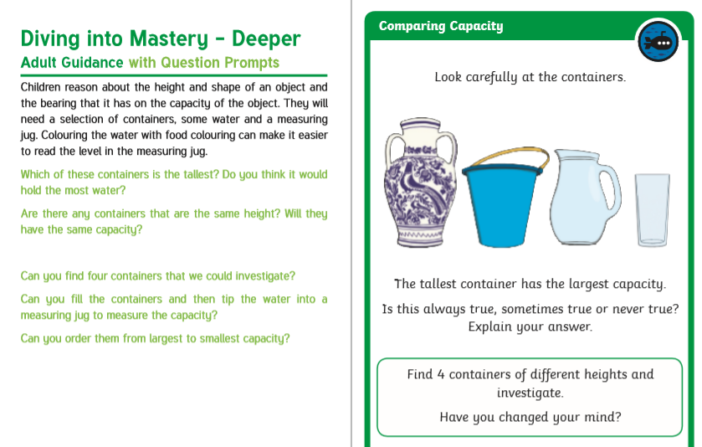
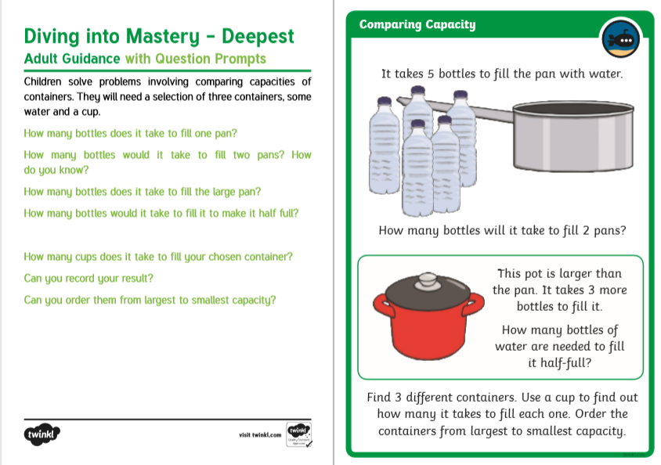
Walt – understand the concept of litres.
Using the internet, books and what you have at home list as many items in the correct columns below.
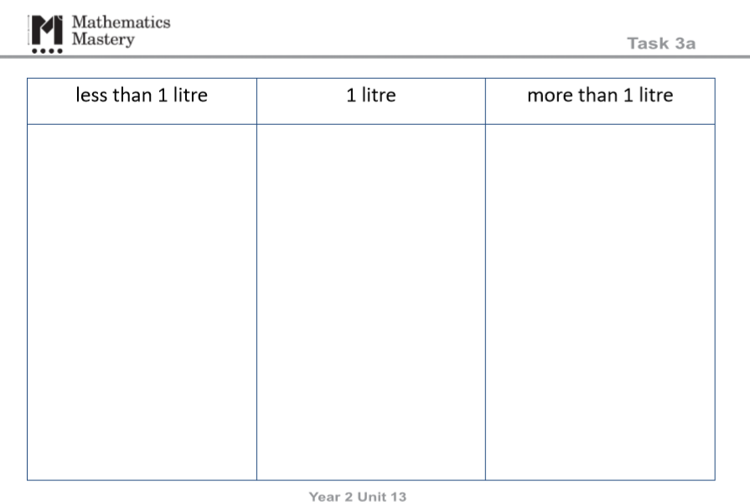

Walt – solve word problems about capacity.

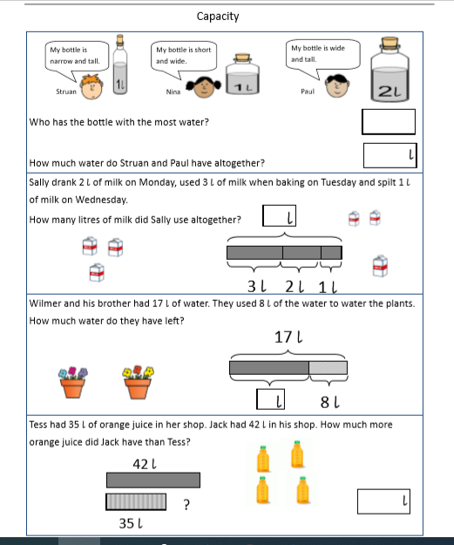
Walt – compare volume using < > =
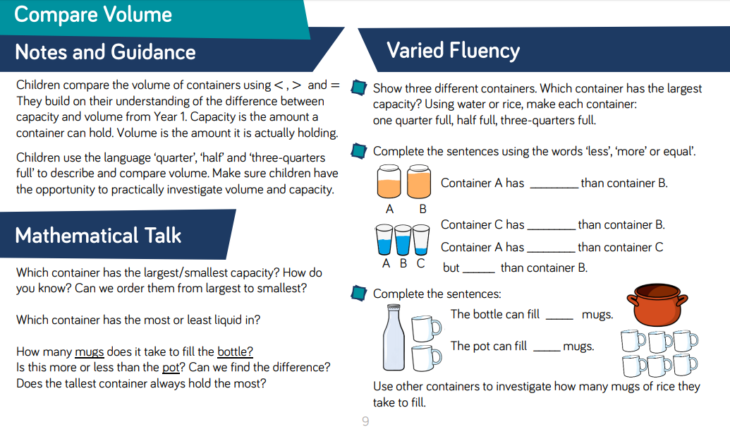

Walt - solve problems that involves volume.
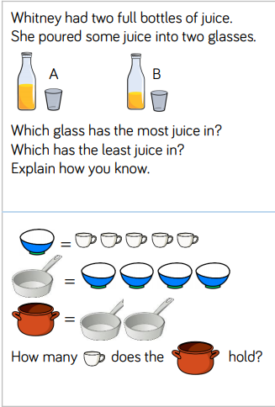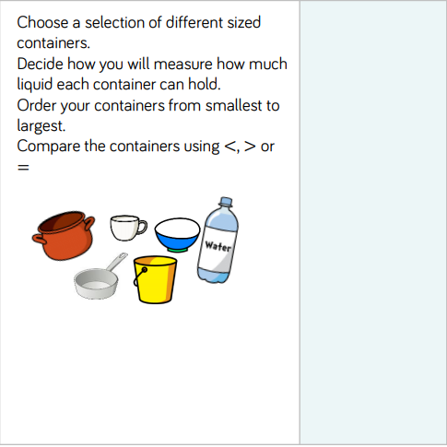

Walt – understand the concept of millilitres.
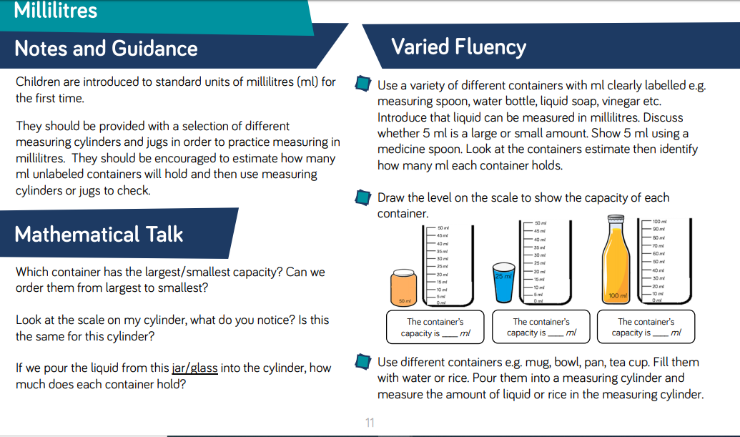

Walt – understand the concept of millilitres.
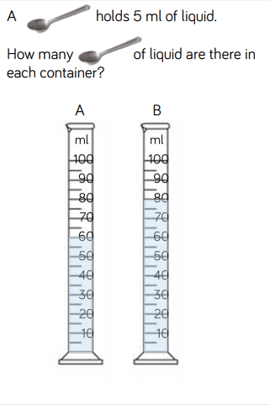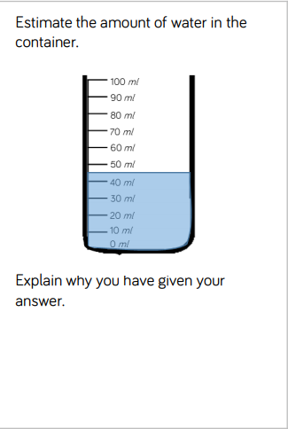
Walt – understand the concept of litres.
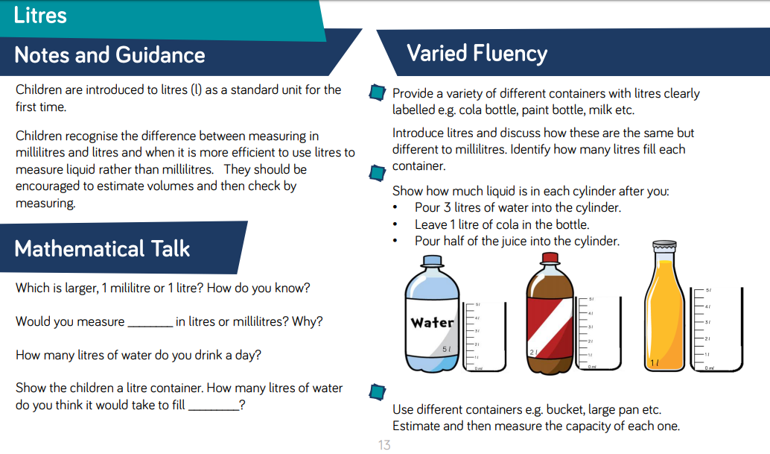
Walt - solve word problems that involve litres.

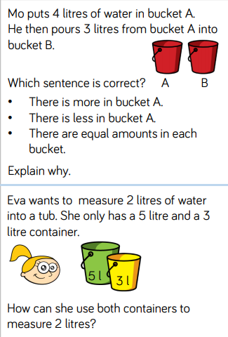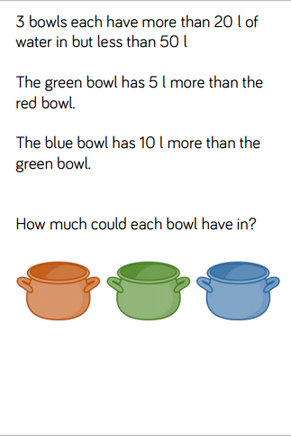
Walt - read the temperature in degree Celsius on a thermometer.
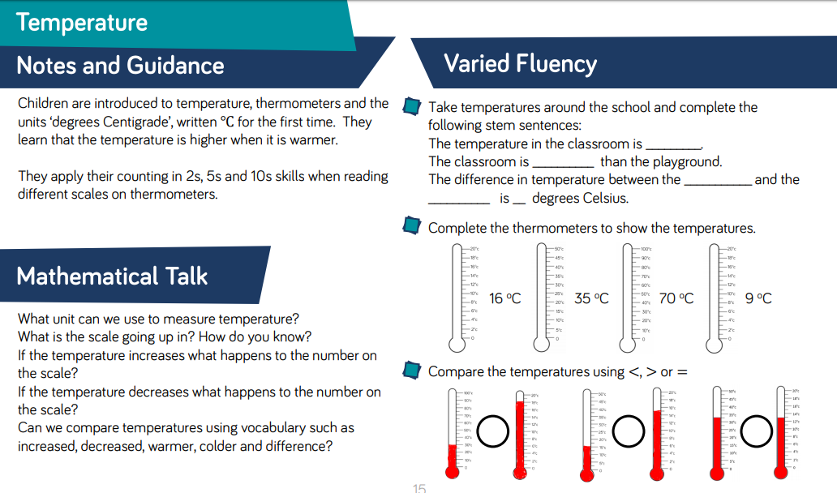

Walt - read the temperature in degree Celsius on a thermometer.
