Words ending with –able, -ible, -ably or -ibly

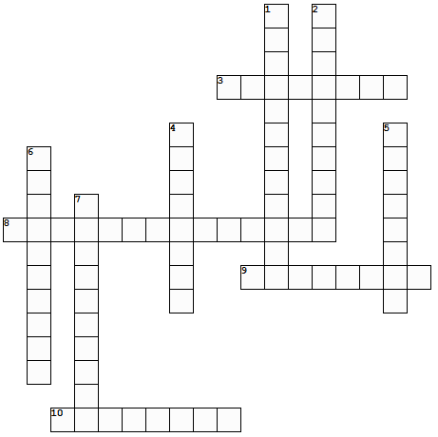
changeable possibly adorable considerable adorably noticeable dependable sensible terribly understandable
Across:
3. maybe
8. able to be understood
9. awfully
10. being practical and functional
Down:
1. notably large in size or amount
2. easily seen
4. doing something in a cute way
5. extremely cute
6. able or likely to change
7. able to rely on something or someone

Answers

