PLANTS 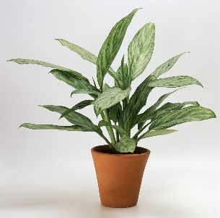

This term in science our focus is on plants. Have a look in your garden or when you go out for walks at the different types of plants. You could compare sizes, colour and height.
What to do?
- Information gathering
Use as many sources of information as you can to find out about one the following:

- The tallest living plant (not flower) in the world
It’s name, how tall it is, where in the world it is found/comes from.

- The oldest living plant in the world
It’s name, how old it is, where in the world it is found/comes from.

- Presentation of gathered information
Present your information about the tallest or oldest living plant in the world in the form of a front page newspaper article – this maybe handwritten or typed.

You must include:
- An eye catching headline
- A picture or diagram
- Plant information – Scientific and common name
- How old or tall it is
- Where in the world it’s found
- A description of the plant
- Any other interesting facts or information about the plant
Remember to include the source(s) of your information
(books, internet)

