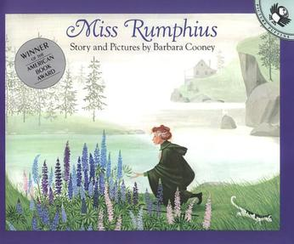
March 26th 2020

Making the World a Better Place

Dear Children,
All across the world children and their families have been asked to stay at home together to reduce the risk of spreading the virus and putting any unnecessary risk on our health service.
It is the adults who are making decisions for the country, imposing restrictions on us all and working around the clock to ensure as many people as possible remain well. BUT, you, the children, have a very important and critical role to play amidst all this change and concern.
As our prime minister, Mr Johnson and his close medical advisors, assures us, we will get through this difficult time, if everyone, including you, help. So how can you help?
You must use this time at home to take responsibility for your own learning, where possible. See this break from school, as a wonderful opportunity to take advantage of all the different learning experiences out there and expand your understanding of the world around you.
All the class teachers at St Michael’s are keeping the class pages updated, weekly, with learning links and lesson ideas. Have a look at all the class pages, there may be a challenge, in another year group, you would like to try. Most importantly, continue to practise your 6Rs and take your learning at home seriously. Make yourselves and your teachers proud of how you have spent your time productively, doing your set tasks, while allowing your parents to continue managing their work commitments from home.
One of the many things I miss about not being in school is being able to read your writing; particularly your recounts, poetry and narratives. Writing, is something we do well at St Michael’s, so I would like to propose we all take the time to compose a contribution to a whole school collection of writing entitled ‘I am Making the World a Better Place’. The choice of genre is yours.
I have attached a Youtube link in this letter to a story that is one of my personal favourites. Many of you will remember me reading this to you at some point. ‘Miss Rumphius’ is the tale of a philanthropist, committed to making this world a better place for others; this is something we can all do. Firstly, please read the story and consider what you can, are doing, to make the world a better place. Then, please email your work to:
headteacher@stmichaelsce.co.uk
Please only send 1 piece of writing per pupil only, for the time being.
Furthermore, inspired by Miss Rumphius, I would like to share my plan of how we, as a school community, can make our village a more beautiful place for everyone to enjoy, when this difficult situation is over.
Over the next few weeks, you will all be receiving some lupin seeds. Please take these with you when you go out locally to exercise with your adults and scatter them, just like Miss Rumphius on gardens and areas of soil in Sunninghill. Instructions for when to plant will be enclosed with the seeds.
Can you imagine the joy your act of kindness will bring when all these lupins are in flower around the village. People’s spirits will be so uplifted because of your thoughtfulness. It gets better! When the flowers fade at the end of the summer, the seed pods will burst, the seeds will be scattered and the cycle will begin again. Sunninghill could become known as ‘The Lupin Village’.
Meanwhile, read the story and get writing!
Please take care, stay safe and be kind to everyone at home, particularly the grown- ups.
With much love and best wishes to you and your families,
Mrs Anderton

Miss Rumphius by Barbara Cooney
https://uk.video.search.yahoo.com/yhs/search?fr=yhs-trp-001&hsimp=yhs-001&hspart=trp&p=miss+rumphius#id=1&vid=d17cd3cee8ab129e4448d5e587c43b36&action=view

