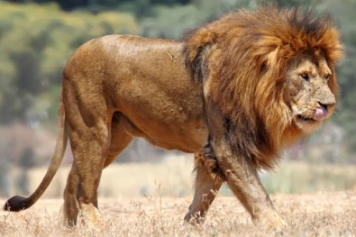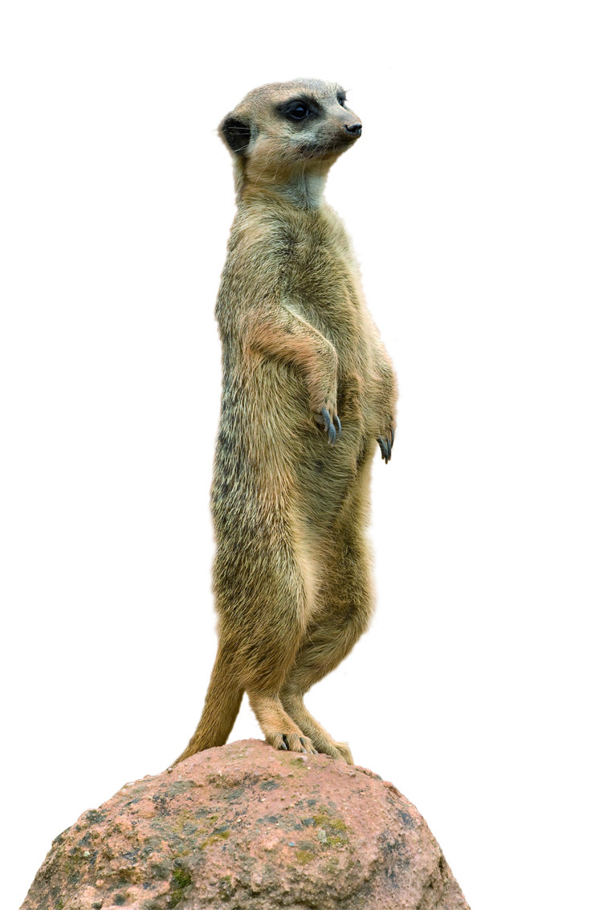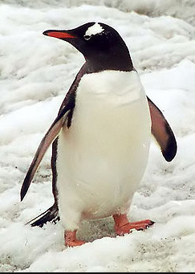

**2.5m**

**2m**

**3m**

Before the lions arrive, you need to work out if their enclosure is big enough! Using the picture below, approximate the area of the lion…

Using your answer above, what would be the area of 3 lions?

Now work out the area of the lion enclosure! Do you think it will be big enough? Give a reason for your answer.

What is the area of the meerkat habitat?

What is the area of the penguin habitat?

The school have decided that you don’t have enough entertainment during your lunch break, so they’re going to build you a zoo next door! Your head teacher has drawn a rough plan, but needs help working out the areas for each of the animal habitats…

Silver

Name__________________

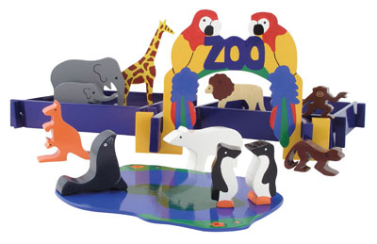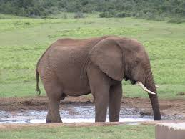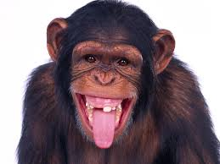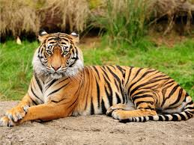

**CHALLENGE!** The school decide that they would also like to build a triangular elephant enclosure! Using the picture of the elephant below to help you, sketch a sensibly sized enclosure for the elephants. Put the lengths on all of the sides, and work out its area.

**5m**

**4m**

**3m**

Given that they are building you a new zoo, the school decide to make some money out of you by building a gift shop! The path either side of the gift shop must be at least 5 metres wide. What is the largest possible area for the new gift shop?

What is the area of the monkey habitat?

What is the area of the tiger habitat?