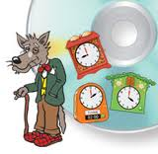
Telling the time
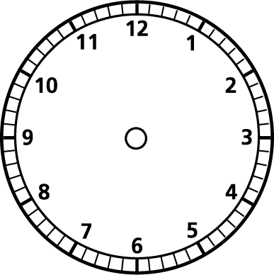
- Show me 3 o’clock on the analogue and digital clock.

- Show me 8 o’clock on the analogue and digital clock.

- Show me half past 5 on the analogue and digital clock.

- Show me half past 6 on the analogue and digital clock.

- Show me 12 o’clock on the analogue and digital clock.

6)Show me half past 9 on the analogue and digital clock.

