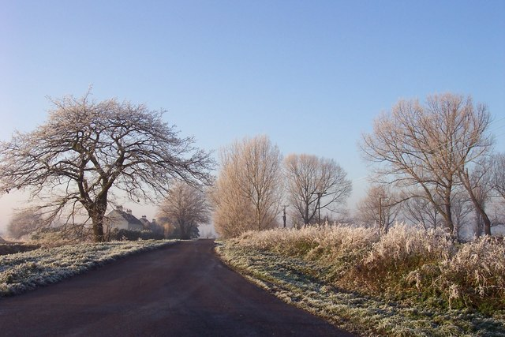

January 15th 2021

Dear Children,

I hope you are having a good day and have enjoyed your learning at home this week. Your teachers are sharing their feedback for your teacher directed tasks; you have been really busy and I am so pleased to learn about your positive attitudes to learning.
Talking of learning, yesterday evening I thoroughly enjoyed looking through the pictures and video clips you have shared, demonstrating the many creative activities and ideas you have explored, to use this time at home wisely and productively. Your resourcefulness is really commendable and I can already envisage the teachers’ challenge, when choosing recipients for the ‘Resilience Certificate’, to be award next week, during our recorded ‘Celebration Assembly’
Yes- I am really looking forward to sharing a ‘Celebration Assembly’ with you next Friday; our families will receive an email next Friday with the necessary link.
If I was asked what I am missing most about this lockdown, it would have to be our fun Friday assemblies, hearing about whole class and individual achievements; why a certain class has been awarded the ‘Golden Spoon’; work for the weekend and, of course, the weekend weather forecast.
In the absence of our resident meteorologist, Owen, the following is a link to the BBC’s weather forecast, for the Ascot area for the coming week.
https://www.bbc.co.uk/weather/sl5
Speaking of the weather, it has been quite chilly in school, some mornings, I have needed to clear the ice on the windscreen before setting off to Sunninghill. Driving through Windsor Great Park, no other cars in sight, trees and railings iced with frost, is the perfect way to start the day. Enclosed by a quiet, white stillness, my thoughts turned to snow and thoughts of how much fun and learning (of course!) this gift, at present, could inspire. Sadly, while we should expect to see ‘sleet’ on Saturday morning, the chance of snow in the coming weeks is slim. For the time being, we will simply have to read poems and stories about snow, to feed our imaginations. The following is one of my favourites, I would be thrilled to receive your personal responses, to this much loved poem; this could include pictures, a short paragraph of writing or, if you are feeling really inspired, your own ‘Snow’ poem!

Stopping by Woods on a Snowy Evening
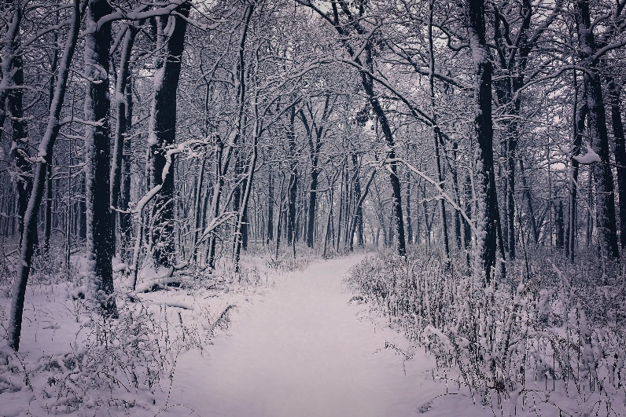
BY ROBERT FROST
Whose woods these are I think I know.
His house is in the village though;
He will not see me stopping here
To watch his woods fill up with snow.

My little horse must think it queer
To stop without a farmhouse near
Between the woods and frozen lake
The darkest evening of the year.

He gives his harness bells a shake
To ask if there is some mistake.
The only other sound’s the sweep
Of easy wind and downy flake.

The woods are lovely, dark and deep,
But I have promises to keep,
And miles to go before I sleep,
And miles to go before I sleep.
I look forward to hearing from you. Please send your replies to your class teachers, who will forward your work to me.

Meanwhile, I am really pleased to share some exciting new online resources to help with your learning, for those moments of reflection and relaxation, during the coming weeks. Many of you will remember Sandy from ising pop, he was a very welcome visitor to school, prior to lockdown. Sandy, together with his colleagues, has made a series of online collective worship videos for us to join in with at home. They are energetic, fun and the Christian message they share is relevant at present, and serves as a reminder to us all that we are never alone. Be sure to encourage your families to join in with you. Perhaps you can teach them the accompanying actions and words?
Parents/carers will be receiving a password via email shortly, to enable you to log on. On the subject of worship, please be sure to visit the ‘Collective Worship’ tab on our school website. Reverend Sarah Mortimer and Reverend Stephen Johnson have collaborated to produce weekly collective videos for our local school communities to enjoy; once again these are fun and there are some great activities to try.
Your teachers and I are so proud of you and how you are seizing this challenging time as an opportunity to develop your skills as independent, life- long learners. Please continue to look after your grown- ups at home and help them as much as possible. Find a cosy place, possibly a cushion den or sofa, to read them a story and give them a hug.
Have a restful weekend.
Take care.
Warmest wishes
Mrs Anderton

