Poetry: 1.06.20

Introduce and read Kit Wright’s poem ‘The Magic box’. See below. You may want to listen to an audio version of this poem: https://www.youtube.com/watch?v=ReP3gVrOfpI or watch this version being read by the author himself: https://www.bbc.co.uk/bitesize/clips/zkpmhyc

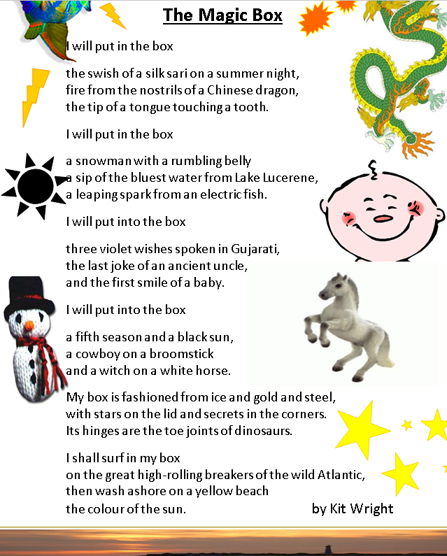

Possible talking points…

What is the title of this poem? Do you know who has written it?
Do you like or dislike this poem? Why?
What sort of things have gone in to the magic box?
What is special about the items in the box?
What was your favourite item? Why?
What do you think is the weirdest item? Why?
What does ‘the last joke from an ancient uncle’ mean?
What is a sari? What is Gujarati?
What was the box made from? Why were the materials chosen do you think?
Would it be actually possible to put the items mentioned in a box?
What do you think makes the box ‘Magic’?
What would you put in your box?

Planning your poem
Now it is your turn to have a go at first planning and then writing your own version of the poem. (This should take at least a couple of sessions)
First, here are some other examples of poems written by other children in a similar style to the Magic box, take a look, what do you think?
https://www.youtube.com/watch?v=7Ses0Io0b5I
https://www.youtube.com/watch?v=s3JRKfHjdLU
https://www.youtube.com/watch?v=dUI08FrPC9A

Make some notes…

What would you want to go in to your magic box?
What interesting sights, smells, textures could you include?
What sort of things are special to you?
What things exist in nature that are the most beautiful or magical? (think about animals, plants, scenery). You might want to look at photographs of our planet and various habitats eg: mountains, rivers, rainforests to get inspired. Think about any places you might have been on holiday. Are there any people that are special or important to you?
Are there any magical things or mythical creatures that intrigue you?
Can you think of anything that would be impossible to physically hold or put in a box?
What would your magical box look like? What materials could your magical box made from?
What will you do with your box once it is full?
Have a go at drawing some of the items for the box to help bring all of your ideas together…

Writing up your poem

Follow the same structure as Kit Wright to write up the poem, and use your notes to help you. Only the absolute best items should make the final version of the poem, don’t feel you have to include all of your notes! Remember there should be 3 lines which list the items you will put in followed by ‘I will put in the box’.

For the last 2 verses describe what your box is made from and then what you will do with it…

Once the poem is written up in neat decorate around the edges of the page with items from your box.

Extension
On completing the task, children could think about other types of boxes, eg: a dream box, a happy box, a giggle box, or any sort of box they like. This could inspire further poetry writing.

Art/DT Challenge!
Perhaps you could find a box, eg: an old shoe box, decorate it and make it your very own magic box? Could you find some items that represent the things that you have put in your magic box?

Other poetry writing tasks for this week
Visit this website to find a wealth of children’s poetry and additional resources that you may want to dip in to… https://childrens.poetryarchive.org/ There are a wide collection of audio clips as well as teaching and learning resources(often quite short and simple ideas) to accompany them and inspire more poetry writing. https://childrens.poetryarchive.org/teach/

