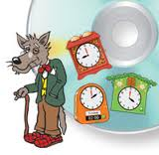
Telling the time
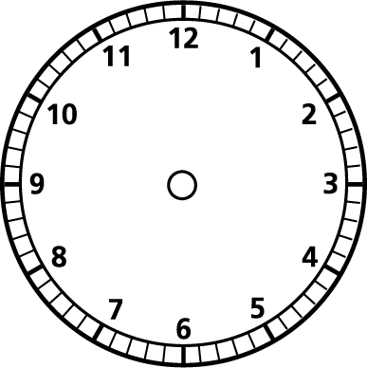
- Show me ten past 2 on the analogue and digital clock.

- Show me twenty past 8 on the analogue and digital clock.

- Show me ten to 5 on the analogue and digital clock.

- Show me twenty five to 12 on the analogue and digital clock.

- Show me five past 3 on the analogue and digital clock.

6)Show me five to 9 on the analogue and digital clock.

