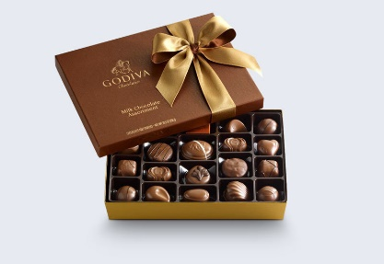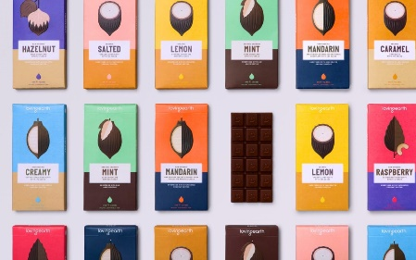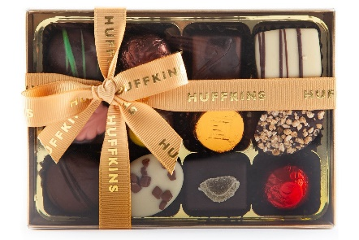
Summer Term 1
Chocolate Packaging
This term in DT we are going to be researching, designing and making packaging for a chocolate bar we’ll be creating.
Lesson 1 – Introduction to packaging (27.4.20) (Keywords highlighted)
There are many different chocolate products on the market (available in shops to purchase). But before products are brought to the market, by law there are many rules and regulations that have to be followed. Attached is a powerpoint explaining some of these rules and regulations. Some slides will be more useful than others and some may find the information overwhelming. You may want to use products you have at home to identify some rules and regulations on packaging.
Activity
- Powerpoint slides 20 and 21 have activities on them. (If you can’t print it off children can write their answers in full sentences on a piece of paper.)
- Alternatively, children can draw and label food packaging from home and write sentences referring to laws, rules and regulations.

Lesson 2 – Creating a mood board (4.5.20)

What is a Mood Board?

A mood board is essentially a collage of images, text and other objects that describe your design ideas (our focus is chocolate) and define the brand. The mood board helps you define the brand identity and often serves as a guide when it comes to doing design work.
- Draw, sketch or cut out pictures of different chocolate bars/boxes. (Twix, Kit Kat, Lindt)
- Try to find examples of different packaging shapes, sizes, nutrition information (front or back of packaging/colour coded), health warnings (allergies), prices, recyclable, clear window to see the product and slogans.

