English: Summer week 1
Key learning: Describing the Chocolate Room
I can use my 5 senses, I can use ambitious adjectives, verbs and adverbs, I can write in the first person and past tense, I can use different openers and conjunctions, I can use correct punctuation, I can edit and improve my writing.

Our new topic this term is all about chocolate and so we thought we would be inspired by Roald Dahl’s novel ‘Charlie and the Chocolate Factory’. Here are some ideas for home learning this week. Please do not feel bound to do this and go at your child’s pace, you may decide to do some elements and not all, or not at all - whatever works best at this time, be aware though that the suggested activities do follow a sequential order. We would love to see any work!

To start off you may want to print and present this ticket to your child to introduce this week’s learning (or hide it somewhere for them to find!) and explain that ‘Today we are going to visit a chocolate room!’
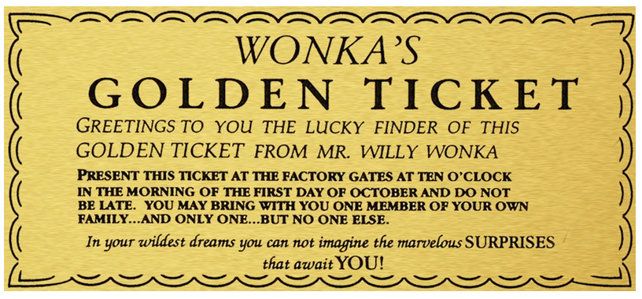

Show the following clip taken from the film and/or read the following text from Charlie and the Chocolate factory.
https://www.youtube.com/watch?v=OMFQtY6655E

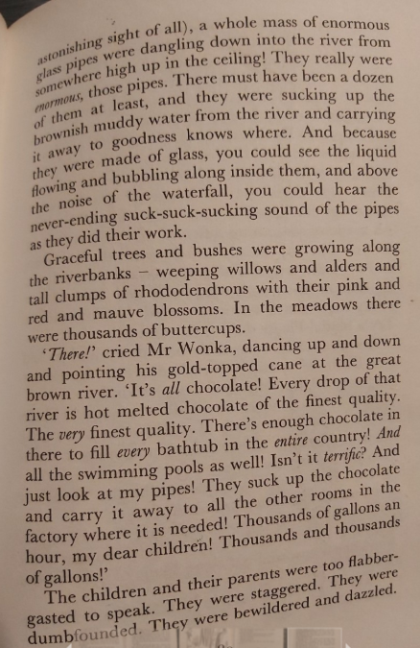
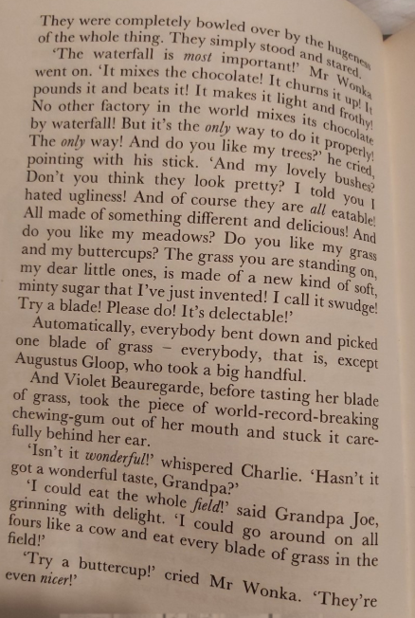
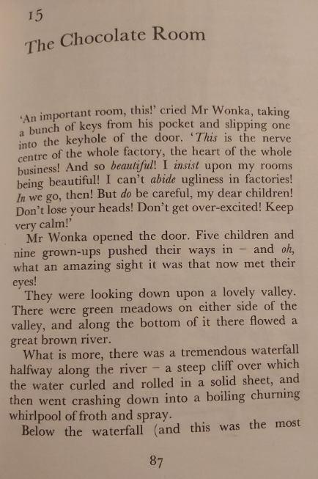

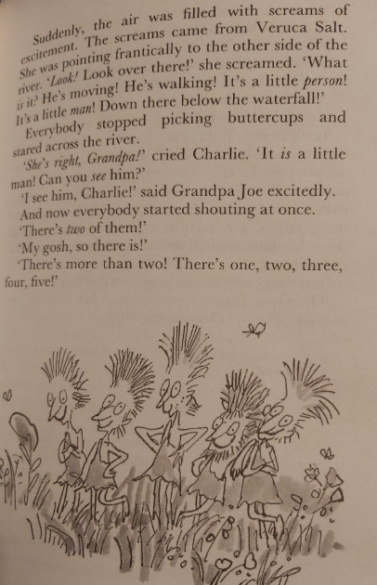
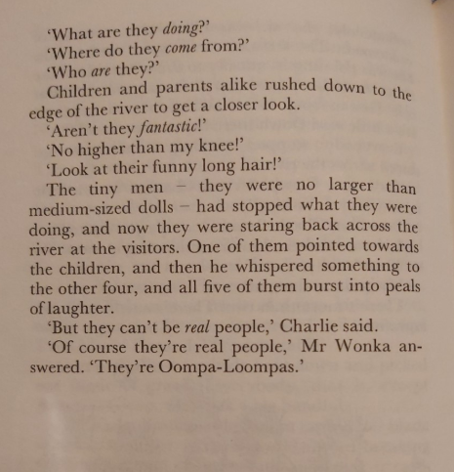

Talking points:
Do you know or recognise the story?
Who is the author?
Would you like to go to a chocolate factory?
What do you think it would be like to be in Willy Wonka’s chocolate factory?
If you have a copy of the book at home have a look through. Or if they have already read it can they recall what happens? Have they seen the film? Is the story used in a film version always the same as the book? Why? Or Why not?

Here are some tasks for the week that lead up to a final piece of writing
- After watching the clip and hearing the story the children may want to start by drawing a scene from the chocolate room. They could include some of the items found in the room: the chocolate river, the waterfall, the candy canes, grass, the butter cups, the Oompah Loompahs, the toffee apple trees, the pipes etc.Let their imagination take over! This could take up to one session if they are enjoying it. It might feel like an art session but this can form the basis for what they will write about! They can add colour and think about the little details. They could even add their own sweet/chocolate inventions. They could look at Dahl’s illustrations or the film screen shots for inspiration (see resources below).

- Next take the time to talk about the scene they have drawn, your child can begin to write adjectives to describe the items in the chocolate room, at first they can think about what they could see colours and shapes, but then build up to words to describe what they can smell, taste, feel, hear. Nouns and adjectives could be put in the table provided or they can use the senses sheet (see resources below). They may want to use the wordbank available or to ‘magpie’ some of the language directly from Roald Dahl’s text. Encourage children to make ambitious word choices and not always settle for the first word they think of, consider using a thesaurus if appropriate. You may extend to finding verbs and adverbs . We have learnt about these word classes at school however some may need a gentle reminder, they are explained on the sheet too.

- To help bring this to life further the children could become professional ‘Chocolate tasters’ just like Roald Dahl used to do for Cadburys when he was young… They could have a go at first closely inspecting any chocolate they have (perhaps left over from Easter). They must really take their time to first look at the chocolate, smell it, and finally taste it, perhaps just a tiny piece (good luck with that!). They should savour the flavours and eat it slowly perhaps they can close their eyes and be mindful when eating. After this encourage your child to talk about the experiences and jot down additional vocabulary to their sheet as they go!

- After gathering a wide range of vocabulary now they will need to use the descriptive words they have created to build sentences they are going to write a description of the Chocolate room, imagining what it would be like to be Charlie. Encourage your child to say the sentence first before writing it, test it out, how does it sound, can anything be added or changed? Children will need to write in in first person using ‘I’ and the past tense (see this week’s SPAG task). See the openers and conjunctions word bank to help develop sentence structure. They can also refer to the example piece of writing, what do they like about it? What don’t they like? If your child knows the story well and as an extra challenge they could consider including interactions and observations of some of the other characters in the chocolate room too. This, forming sentences stage will probably take the most time and you may want to spread across 2 sessions.

- Now for the editing/proof reading stage, (children often find this difficult and so lots of praise and positives always helps). Before editing their own, they may want to have a go at ‘Being the teacher!’ and editing the example piece of writing with lots of mistakes (see resources below) how many mistakes can they find? Now Ask the children to reread what they have written aloud. Celebrate what they have achieved! What went well? Now, can they spot any mistakes themselves? They may want to write in a green pen to make improvements. Encourage them to think about punctuation, any missed words, and where word choices could be improved, spelling (focus on some key words and not all!). They could read and tick the success criteria as they go if that helps direct them.

- After changes have been made the children could then write up their chocolate description in their neatest hand writing on pretty paper, in the shape of a chocolate bar or to go alongside their piece of art. Alternatively they could always type it up on Purple Mash and email it to us. Or send us a picture. We would love to see any work they’ve done!

Resources

Noun  (thing, person, place,) | Adjectives  (describing the noun) | Verbs  (action word) | Adverbs  (describes the action)
Example: Waterfall | delicious, rich, tall | gushing, splashing, crashing | quickly, fast

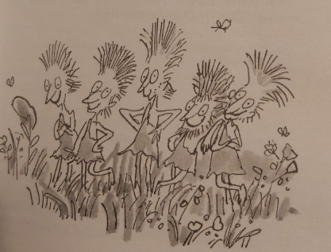
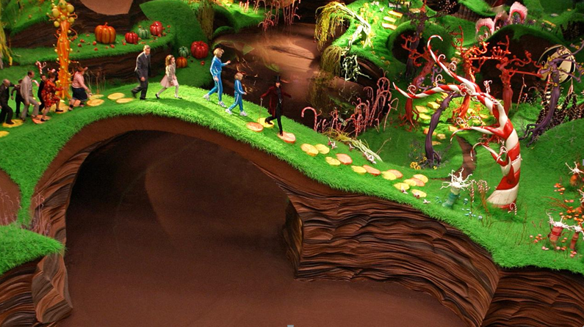
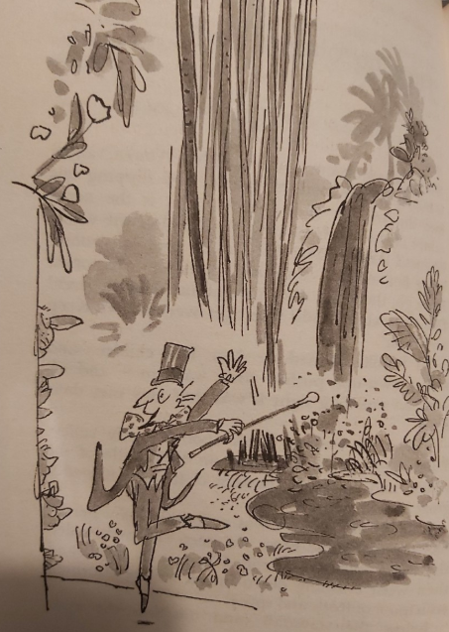
The Chocolate Room…
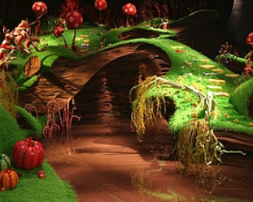

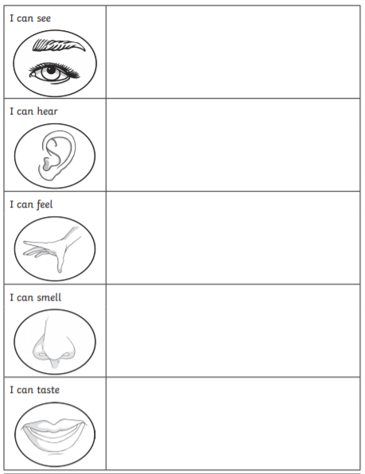
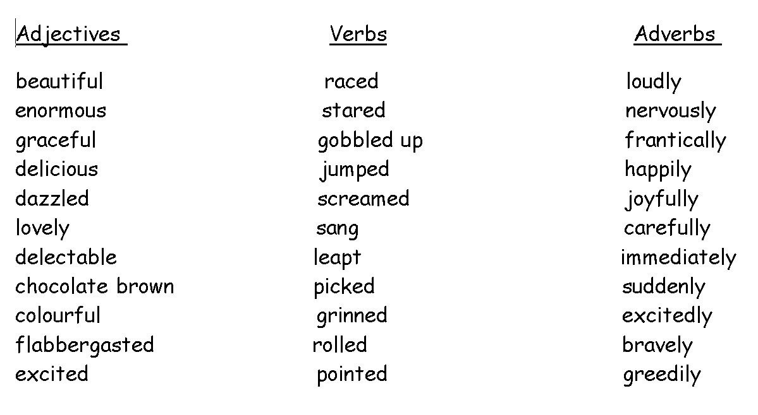
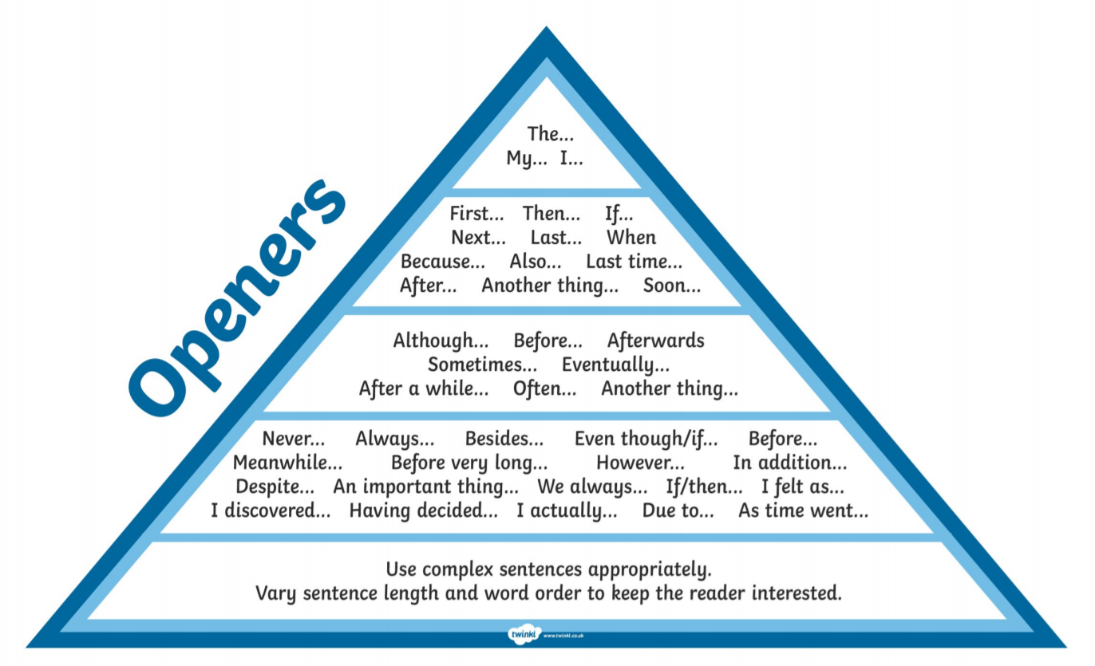

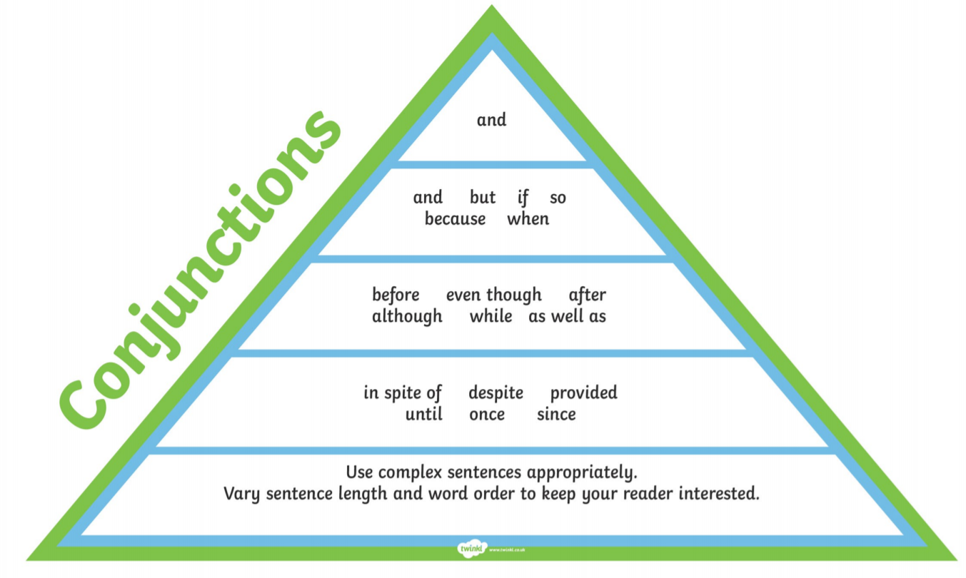

Time to be the teacher!
Make any corrections and improvements that you think are needed….

As willy wonka opened the heavy wooden gAte I raced quickly through so beautiful the first thing I saw was the huge

chocolate waterfall crashing down. I drunk from thE large pool below becos it smelt like heaven. next I carefully

picked sum ov the tender green grass blades so I could try that to. It was soft sweet and nice. “Wow” I could stay here

all day” I say back to willy wonka and the other stunned children. Suddenly, I find myself running exciTdly across the

bridge as I wanted to tuch the bright butter cups they felt smoove and soft and smelt like warm hunny. This was

surely the best place on earf.

What do you think went well?

Even better if?
Example text
As Willy Wonka opened the heavy wooden gate I raced quickly through. So beautiful! The first thing I saw was the huge chocolate waterfall crashing down gracefully. I greedily drunk from the large pool below because it smelt like heaven. Next, I carefully picked some of the tender green grass blades so I could try that too. It was soft, sweet and delicious. “Wow!” I could stay here all day!” I shouted happily back to Willy Wonka and the other stunned children. Suddenly, I found myself dashing excitedly across the bridge as I wanted to touch the bright butter cups. They felt smooth and soft and smelt like warm honey. This was surely the best place on earth.

My success criteria… | Self-assess
I have described the chocolate room in detail
I have used ambitious adjectives verbs and adverbs
I have written in first person - I
I have written in the past tense
I have used openers and conjunctions
I have used all punctuation correctly
I proof read and made changes to my writing

