Maths Week 3

Practising speed of recall for addition and subtraction facts within 20.
Please visit:
https://www.topmarks.co.uk/maths-games/hit-the-button
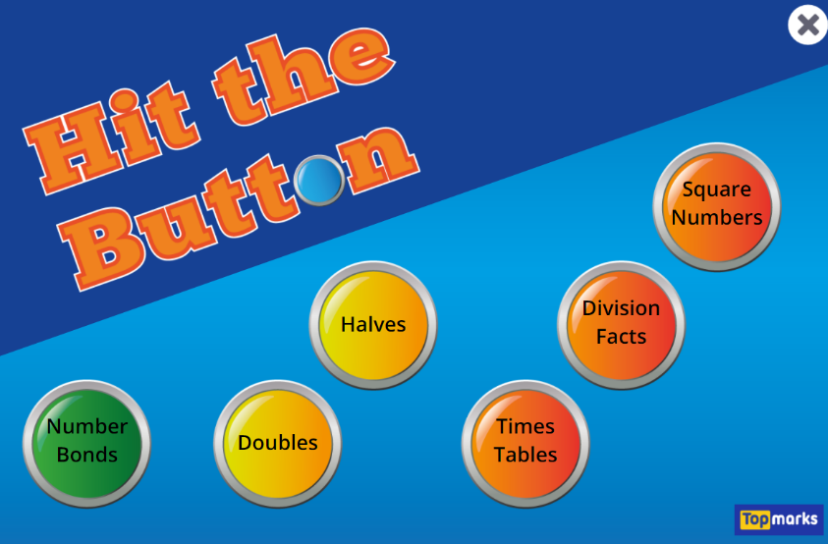

This week the children should see how many questions they get correct in the time given, make a note of their score and then repeat several times to see if they can improve on it.
Please work on addition and subtraction, both of which we have been working on in class.
Extension: addition and subtraction within 100

