Writing tasks, Summer term week (4.5.20)

Key learning for the week:
- To read a passage of text (shared reading)
- To find key information from a text (VCOP).
- To plan and write a character description /character profile of Willy Wonka
(appearance and personality)
- To use interesting adjectives and verbs in my description.
- To choose another character from the story to describe.
- To proof read my writing and make improvements.

Talking points before you start…
Who is Willy Wonka?
Which book is the character from?
Who is the author?
Do you know anything about him? (his job? Personality? Appearance?)
Would you like to own your own chocolate factory?

Roald Dahl’s Character Description
Below is an excerpt from Charlie and the Chocolate Factory by Roald Dahl. It is when we first meet the character Willy Wonka and it is a very good example of character description Read the passage of text together…
Different examples of VCOP can also be found in the passage. How many can you find? Use the following key:
TASK: highlight descriptive vocabulary yellow, conjunctions green, sentence openers red and punctuation blue.

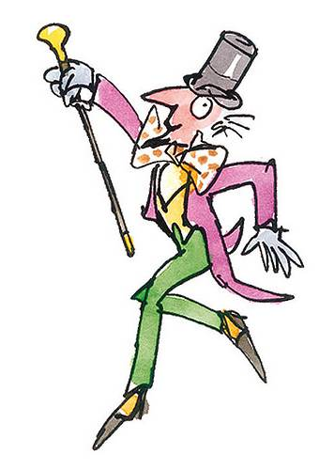
Mr Wonka was standing all alone just inside the gates of the factory. What an extraordinary little man he was!
He had a black top hat on his head. He wore a tail coat made of a beautiful plum-coloured velvet. His trousers were bottle green. His gloves were pearly grey and in one hand he carried a fine gold-topped walking cane.
Covering his chin, there was a small, neat, pointed black beard – a goatee. Oh, his eyes – his eyes were most marvellously bright. They seemed to be sparkling and twinkling at you all the time. The whole face, in fact, was alight with fun and laughter.
How clever he looked! How quick and sharp and full of life! He kept making quick jerky little movements with his head, cocking it this way and that, and taking everything in with those bright twinkling eyes. He was like a squirrel in the quickness of his movements, like a quick clever old squirrel from the park.
Suddenly, he did a funny little skipping dance in the snow and he spread his arms wide and he smiled at the five children who were clustered near the gates and he called out, “Welcome, my little friends! Welcome to the factory!” His voice was high and flutey. “Will you come forward one at a time please,” he called.

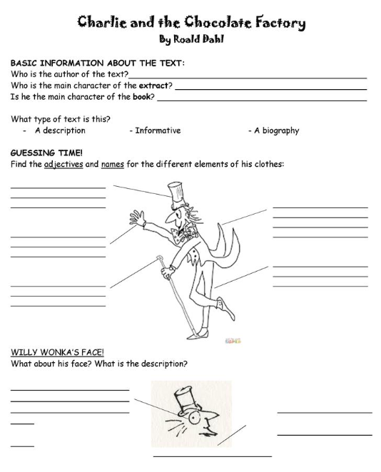
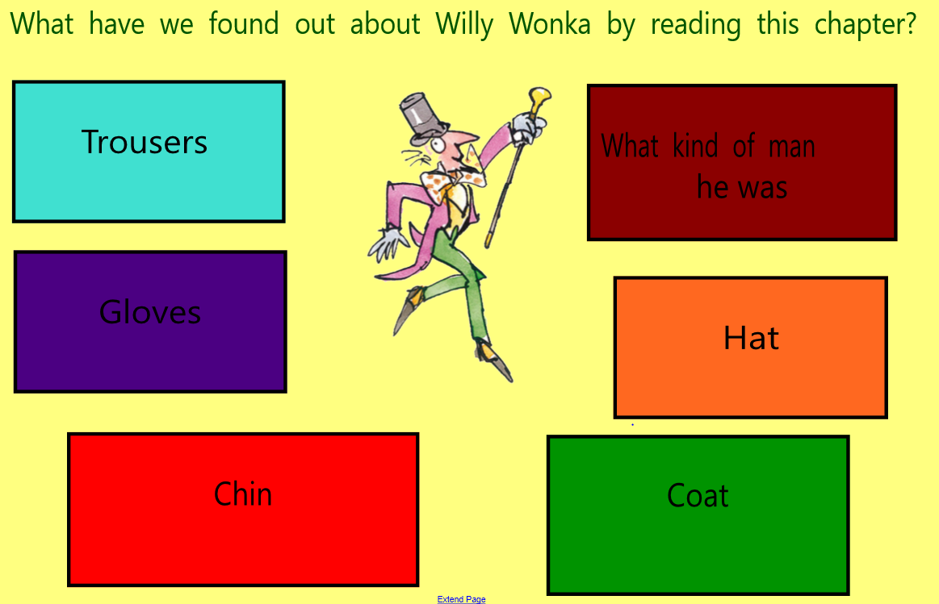

Sentence openers…
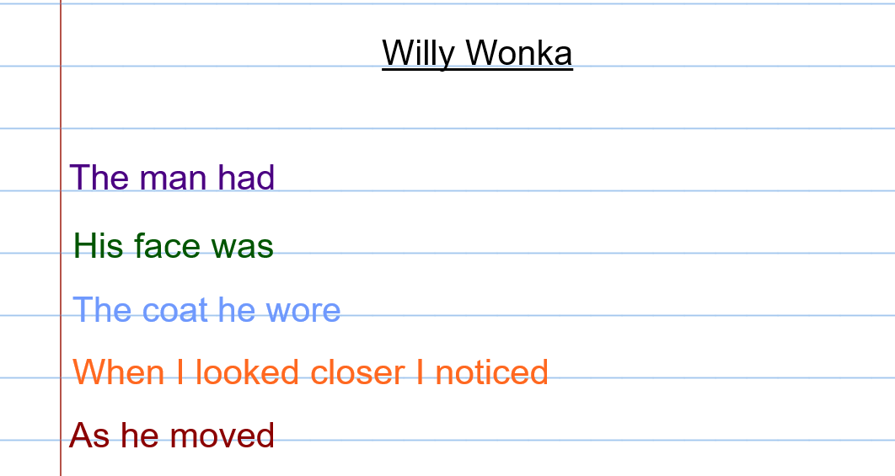

Here are several templates you could use to plan your character profile. You could then use these notes to write more of a detailed a paragraph about Wily Wonka.

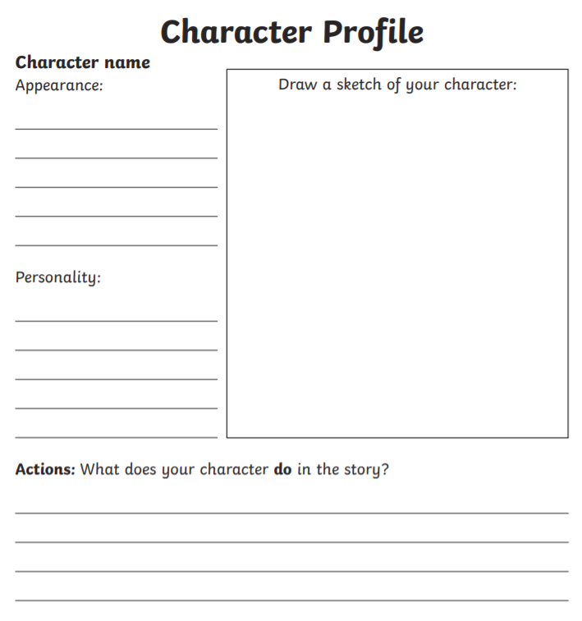

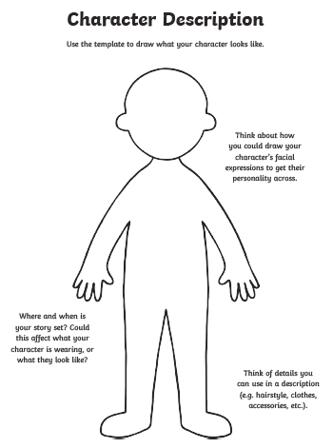
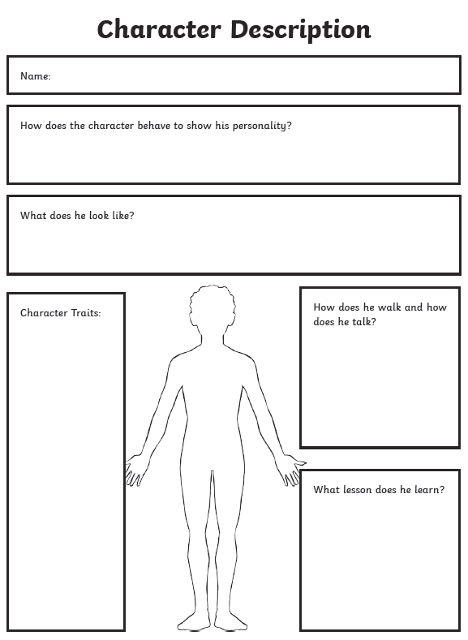

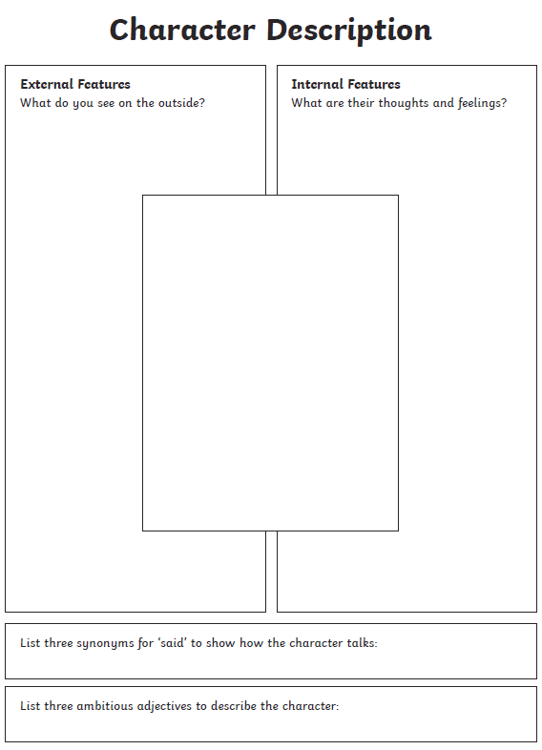

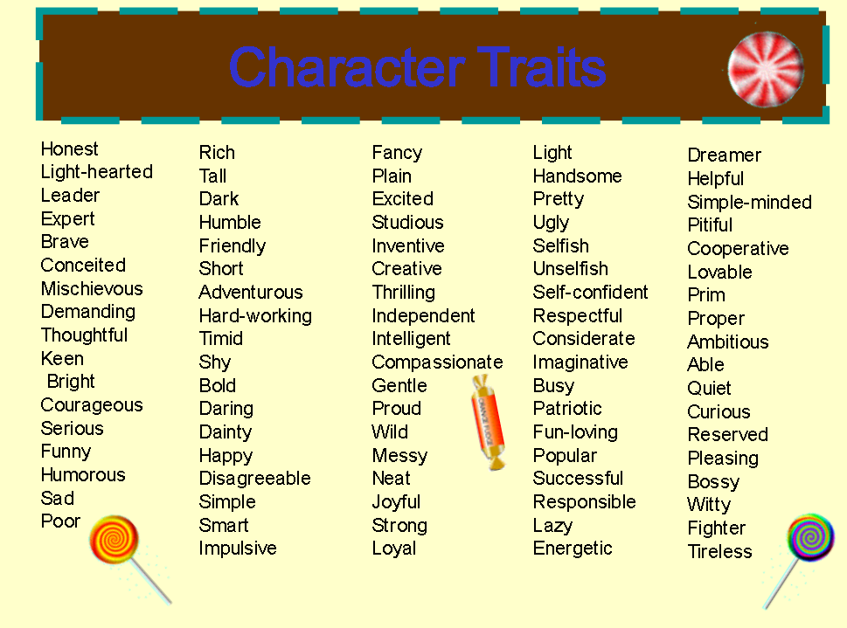
Vocabulary word bank

Do you know any of the children characters from the Charlie and the Chocolate Factory story?
You might want to watch this montage of the ‘4 rotten children’ taken from the film.
https://www.youtube.com/watch?v=zslNn8Cd0-A
If you have a copy of the book at home see if you can locate Roald Dahls descriptions of the children.
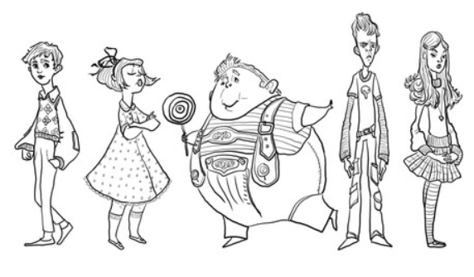
Which one is your favourite and why? Now have a go at writing a character profile for them using a template from above. When you have done this you may want to use the following templates to write up your notes in to a paragraph.

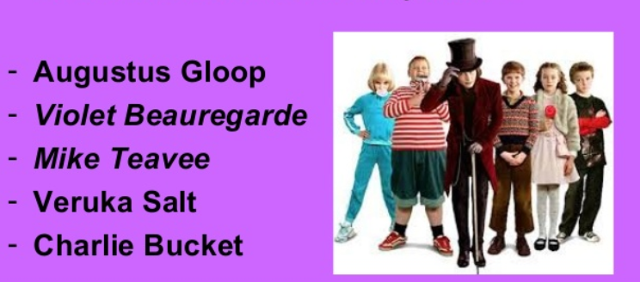

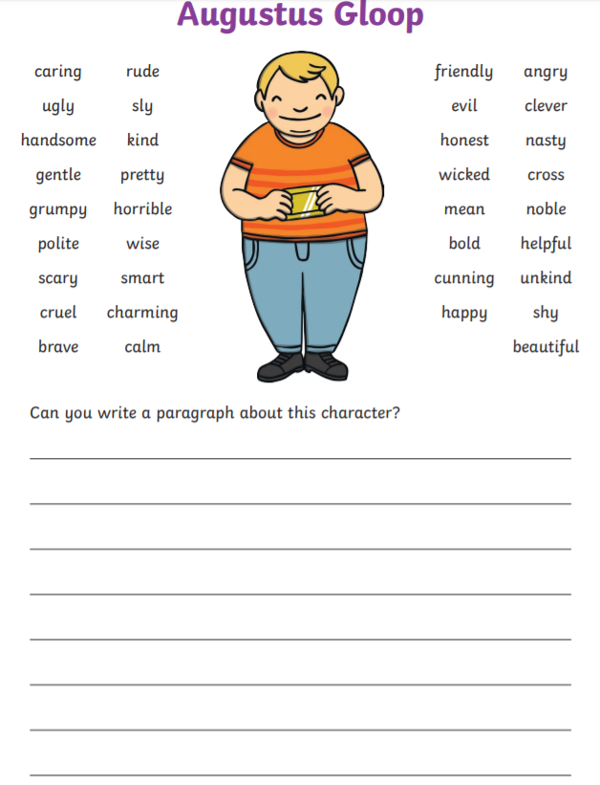

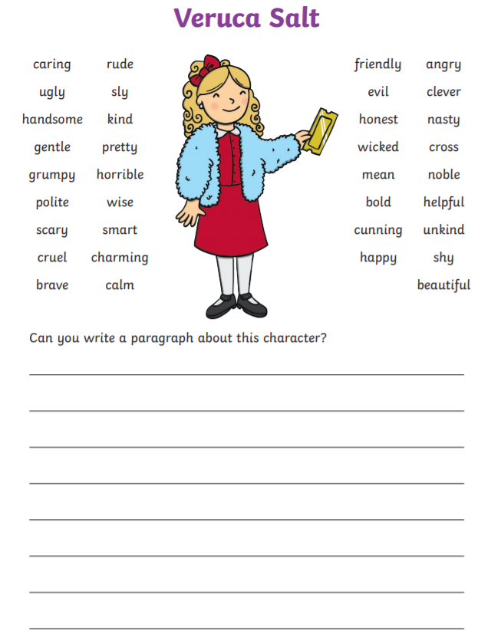

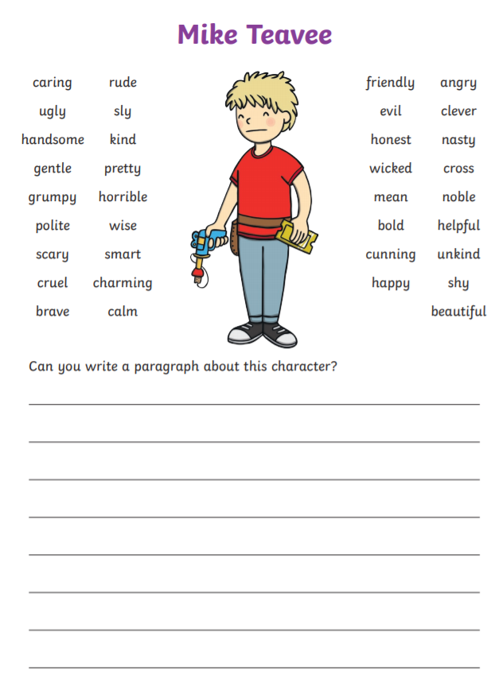

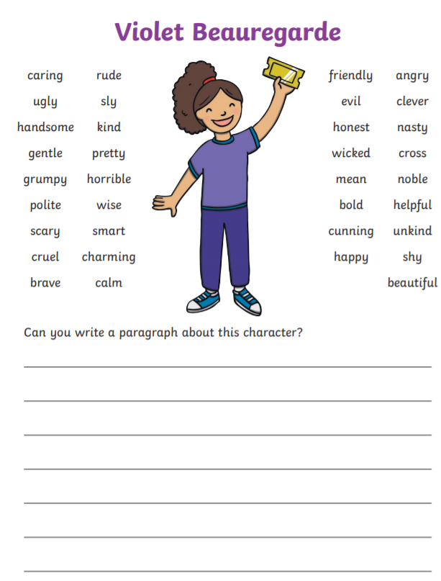

Top Trumps
Have a go at making your own top trump cards for the main characters of the story. See examples below …
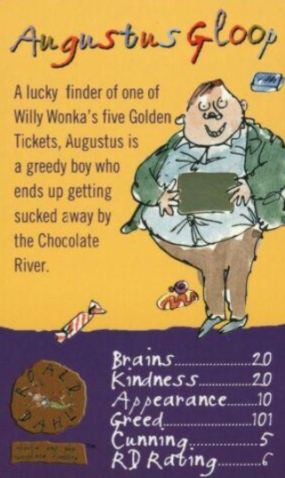
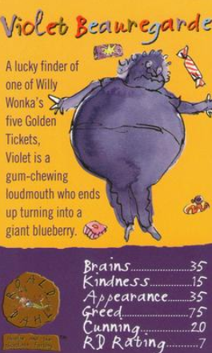

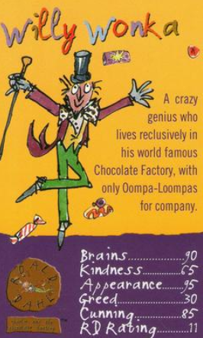

Top Trumps Template…

