Likes  What caught your attention? What made you want to keep reading? What did you like about the text, characters, setting etc? | 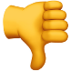 Dislikes  Was there anything you didn’t like or put you off reading? Is there anything you would change?
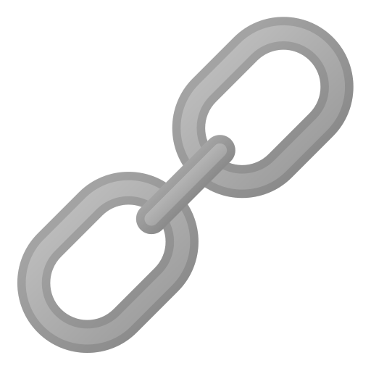Patterns  Were there any patterns you noticed? Did it remind you of anything? Did anything repeat? | 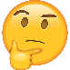Puzzles  Was there anything you found strange or surprising? Is there anything you want to know more about?

