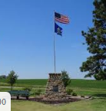
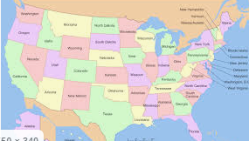
Brain Builders Y5 Doves Autumn 1
Choose one of the 50 states of the USA. Imagine you are working for the tourism board or chamber of commerce (business) for that state. How would you encourage people to come and visit, work in or live in your state? Show your research by creating advertising for the state. This can be through a fact file, a magazine or newspaper advert, a script for a radio or TV commercial, or any other creative way to show you have an understanding of that state!
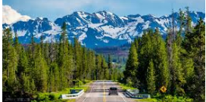
You have a double page spread in which to complete this task. You may use photos and pictures. You can create a pull / fold out section to extend the space available. Due in Friday 9th October 2020

Brain Builders Y5 Doves Autumn 1
Choose one of the 50 states of the USA. Imagine you are working for the tourism board or chamber of commerce (business) for that state. How would you encourage people to come and visit, work in or live in your state? Show your research by creating advertising for the state. This can be through a fact file, a magazine or newspaper advert, a script for a radio or TV commercial, or any other creative way to show you have an understanding of that state!
You have a double page spread in which to complete this task. You may use photos and pictures. You can create a pull / fold out section to extend the space available. This task should be handed in by Friday 9th October 2020

