Home learning maths
Summer term, week 1: 20.4.20

Suggested key areas of learning for year 2 this week:
Place value of 3-digit numbers…
- To recognise the place value of each digit in a 3-digit number
- To be able to show the value of a 3-digit number in more than one way
- To compare numbers within 1000 using the <, > and = signs
- To accurately read scales within 1000 units
Feel free to use resources provided across this week, you may choose to take one area for each day, with a recap on Friday or if this feels like too much pick and choose areas of learning and spend longer on areas found difficult. Please do not feel that you child has to complete every single resource provided, in many cases there is a range of difficulty so you may prefer to choose the most suitable.
You may want to source your own materials in addition to or instead of the ones we have provided to meet the needs of your child. Take a look at websites such as Twinkl or TES for ideas.
To keep things light you may want to start your maths session with a short fun practical starter activity eg: a game relating to timestables, using money and giving change, hit the button, naming and describing shapes, counting songs, splat the number square (see our links page for ideas), measuring or weighing objects found in the house, looking at the calendar, naming days and months, reading the time.

To recognise the place value of each digit in a 3-digit number
Match the numbers to the correct picture
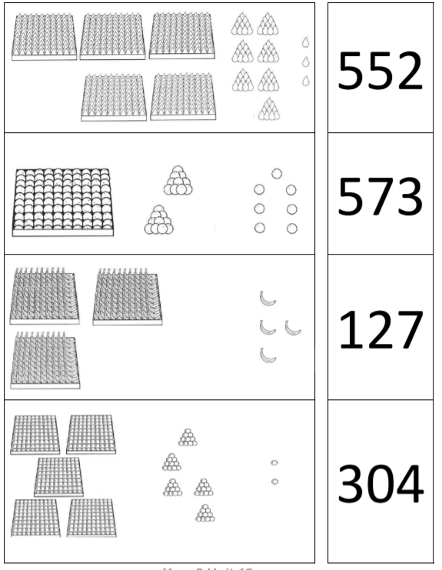

To recognise the place value of each digit in a 3-digit number
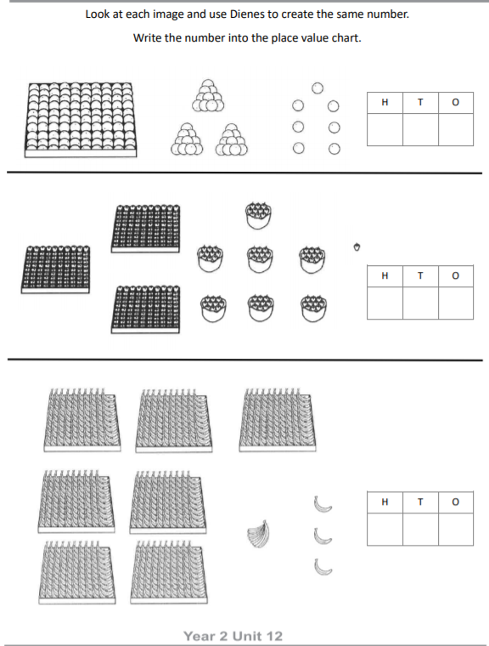
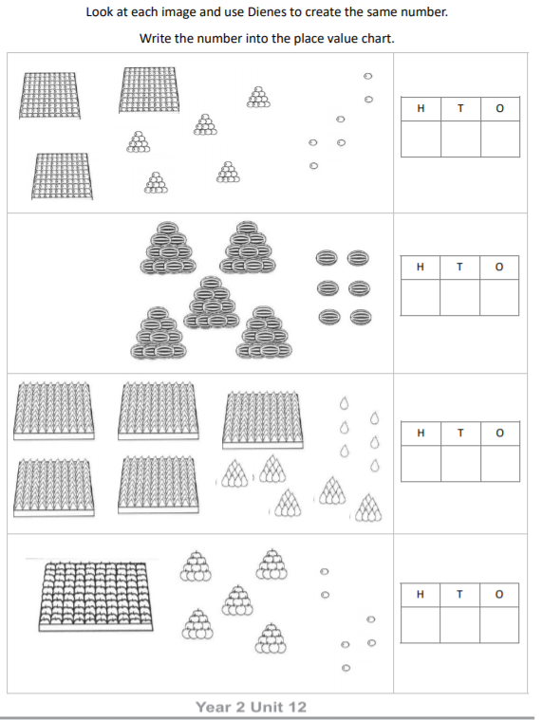
To recognise the place value of each digit in a 3-digit number

To recognise the place value of each digit in a 3-digit number
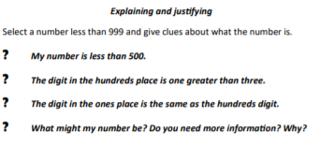
You may want to try the place value dice game
Your aim is to compete to make the largest three-digit number possible. Draw three dashes each with your name by your set, each of the three dashes represent the hundreds, tens and ones value. Take it in turns to roll the dice, place the number rolled in the best possible position to make the highest number. You could use this 9 sided dice resource if you don’t have a dice at home: https://dice.virtuworld.net/?sides=9

H t o
___ ___ ___ (Mrs Guy)

___ ___ ___ (Mrs Field)

Now say your 3 digit number our loud, who was the winner?
Could you have got a higher number with the numbers you rolled if you rearranged the digits?
What was the lowest possible number you could have got with the numbers rolled?
What is the difference between the two numbers?

To be able to show the value of a 3-digit number in more than one way
Show as many different ways as you can of making the number 524…
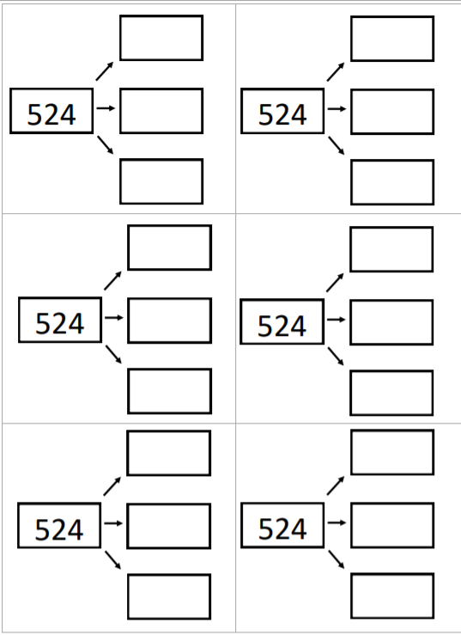

To be able to show the value of a 3-digit number in more than one way

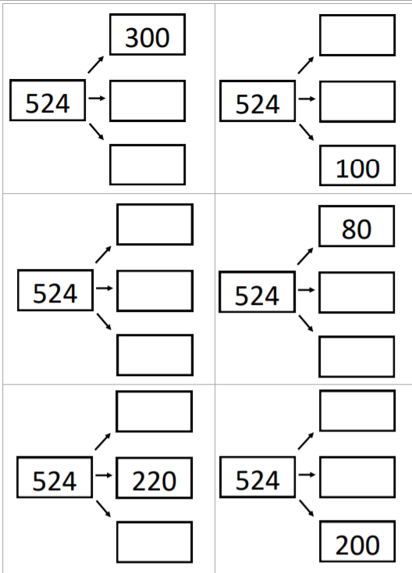

To be able to show the value of a 3-digit number in more than one way

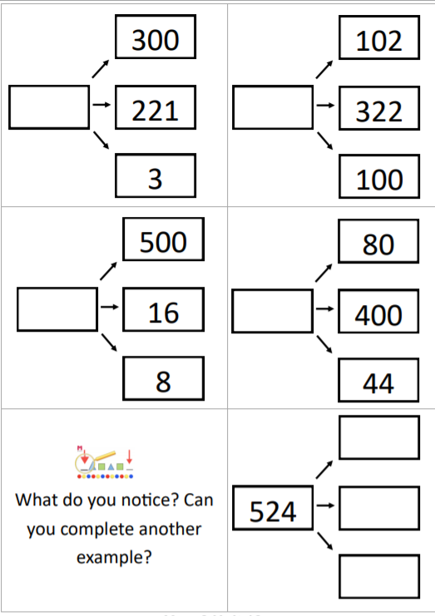

To be able to show the value of a 3-digit number in more than one way

Match the number cards with the correct dienes pictured below…
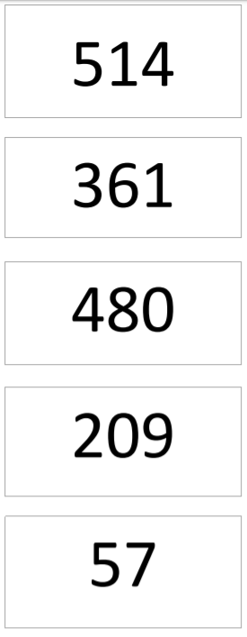

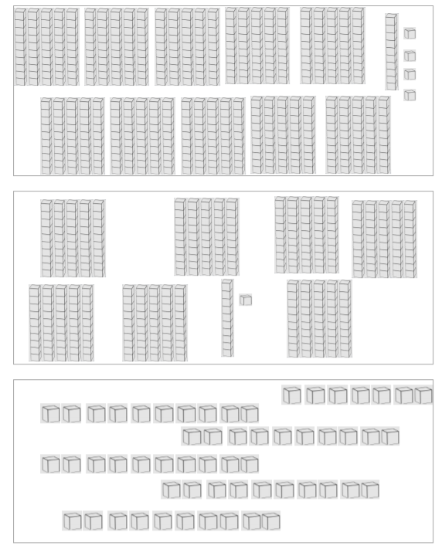

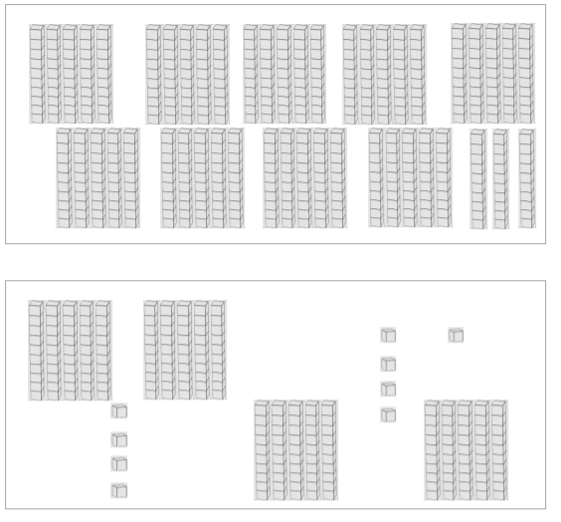

To compare numbers within 1000 using the <, > and = signs
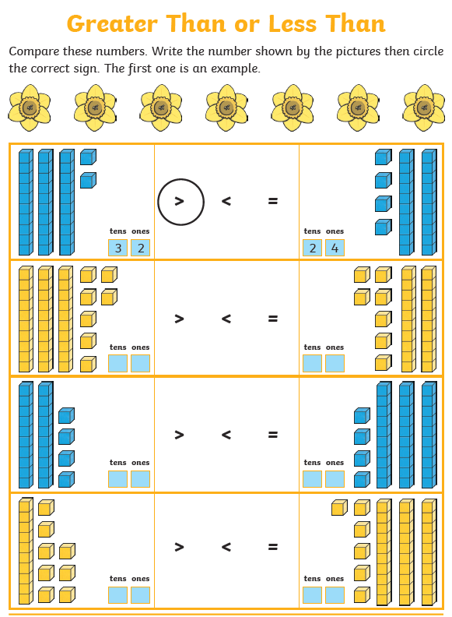
To help the children remember the < and > symbols they can think of the open jaws of a crocodile munching the larger number. Once they have completed the sheet, ask them to read aloud the first number followed by the symbol name and finally the second number to ensure they have fully understood.
To compare numbers within 1000 using the <, > and = signs
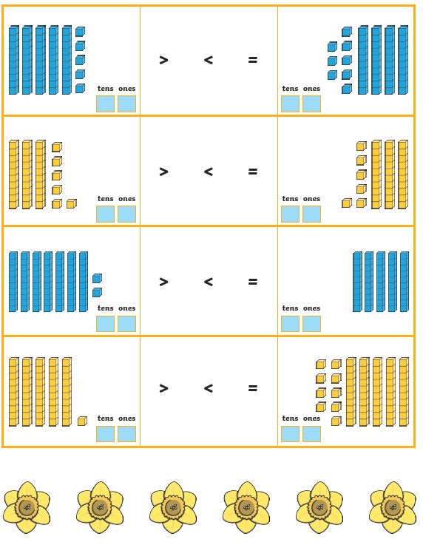

To compare numbers within 1000 using the <, > and = signs
Comparing numbers…
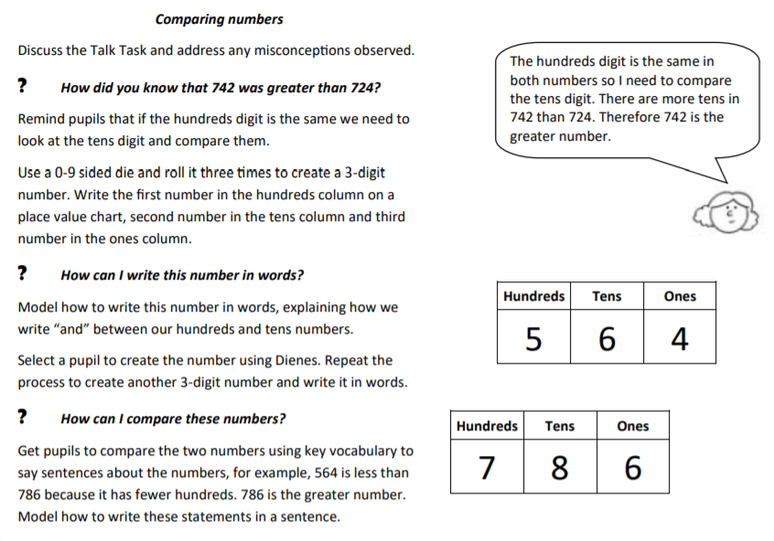

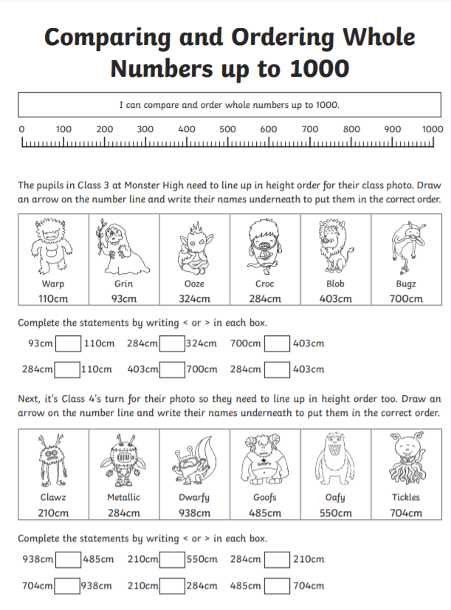
To compare numbers within 1000 using the <, > and = signs

To compare numbers within 1000 using the <, > and = signs

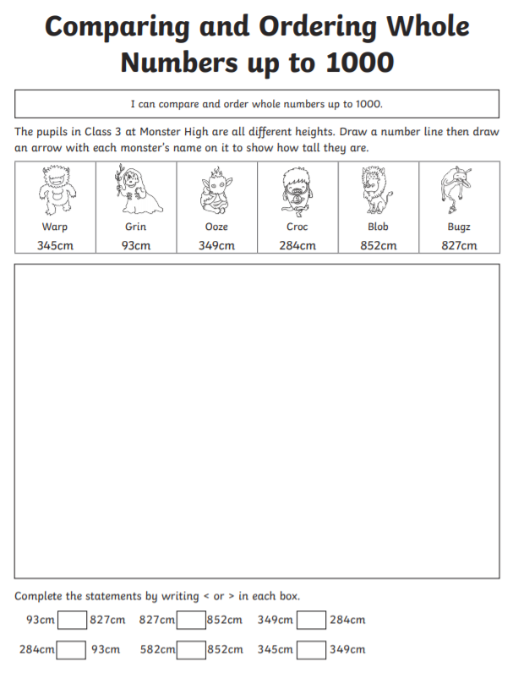

To

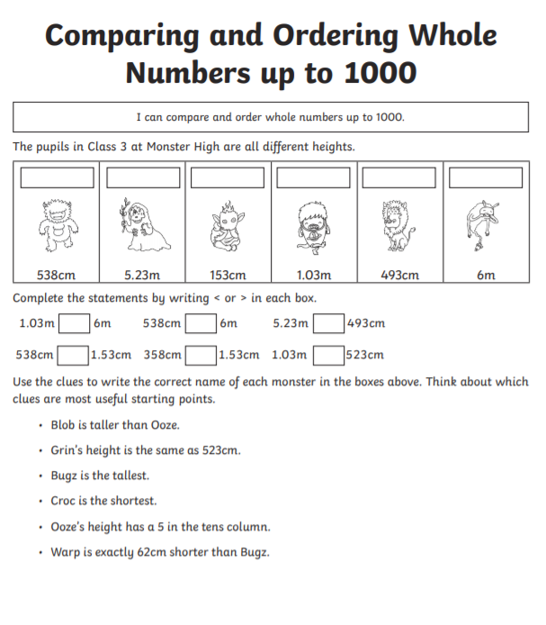
To compare numbers within 1000 using the <, > and = signs

To accurately read scales within 1000 units

For this session it would be beneficial to look at a set of kitchen scales if possible. Talk about the divisions and what each line represents. Encourage the children to experiment with weighing different items and reading the scales.
Perhaps link with a bit of baking. Discuss why scales are important and when you might need them.

Children could try this Mostly Postie weighing game
https://www.ictgames.com/mobilePage/mostlyPostie/

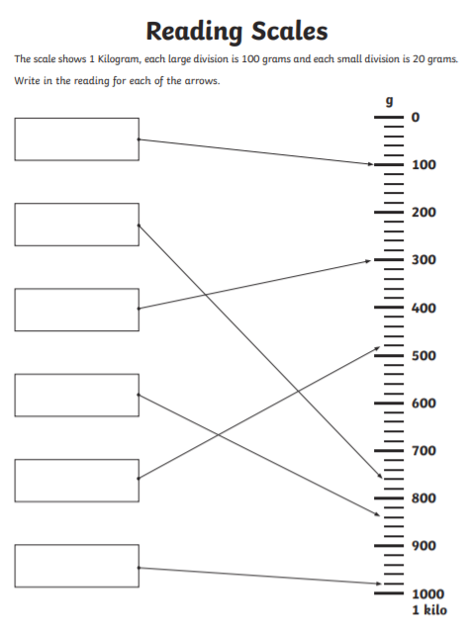
To accurately read scales within 1000 units

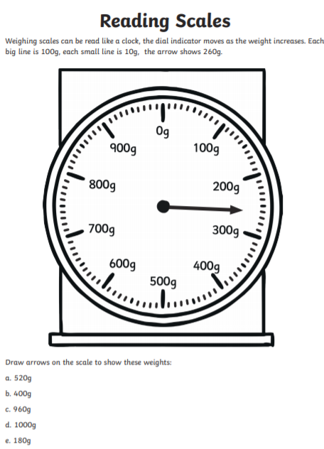
To accurately read scales within 1000 units

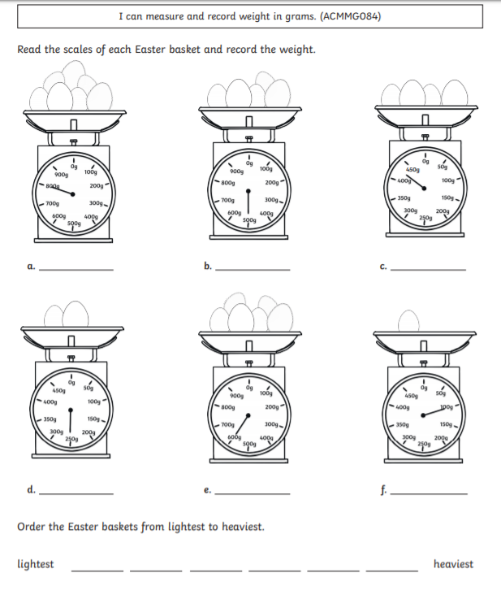
To accurately read scales within 1000 units

