Writing tasks, Summer term week 2 (27.04.20)

Key learning for the week:
- To read and discuss Chocolate poems from Children’s author Michael Rosen.
- Answer questions about poetry.
- Begin to understand poetic devices: onomatopoeia, alliteration, and similes.
- Write a poem about your own favourite food.
- To learn and recite a poem confidently and with expression.

Chocolate poem number 1:
Watch this poem on you tube.: https://www.youtube.com/watch?v=tWrOeNKvtHI
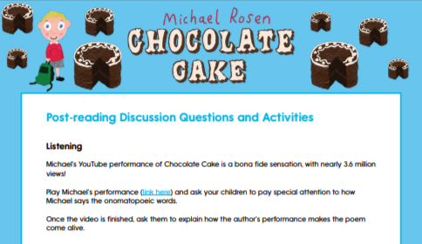

Chocolate poem number 2:
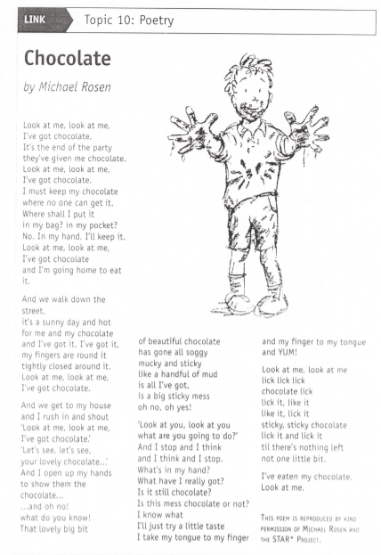

Talking points
Which poem was your favourite and why?
What did you think of Michael Rosen’s performance?
What did he do so well?
What was your favourite part of each poem?
What sort of words can you see in the poem?
Have you ever been tempted to eat something that you shouldn’t?
Is there a time where you’ve had to resist temptation?
How are these poems different from other poems you might have read before?

Have a go at reading some parts of the poem aloud together using a loud clear voice and with intonation in your voice. Can you include facial expressions?

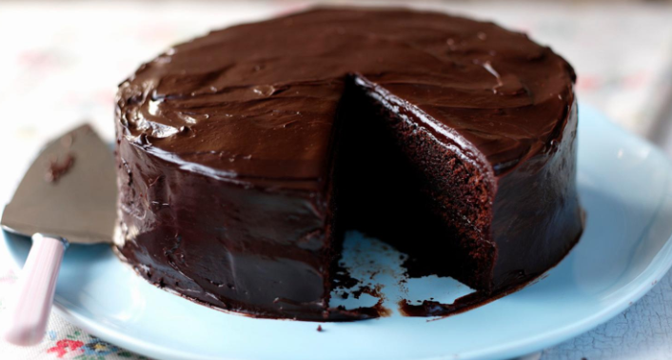

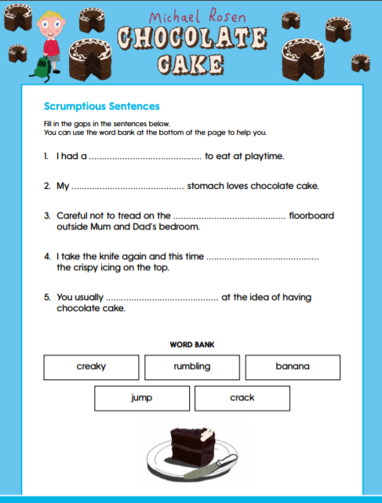

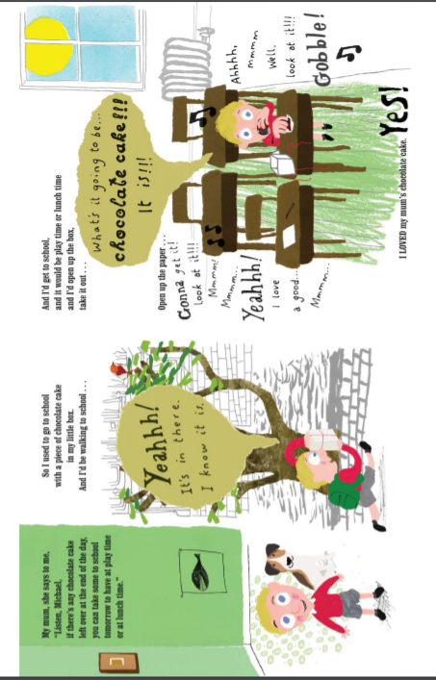

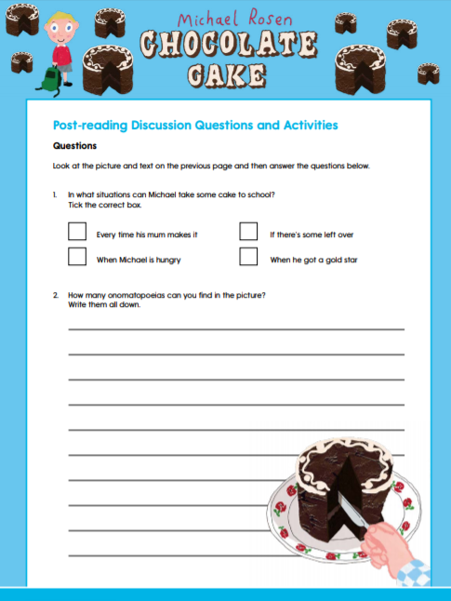
Understanding poetic devices…
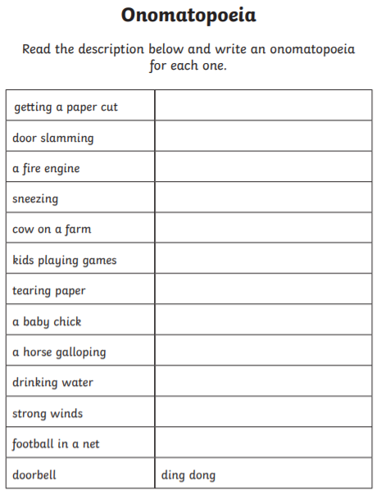

Understanding poetic devices…

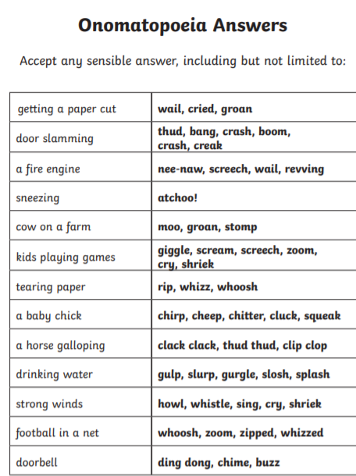

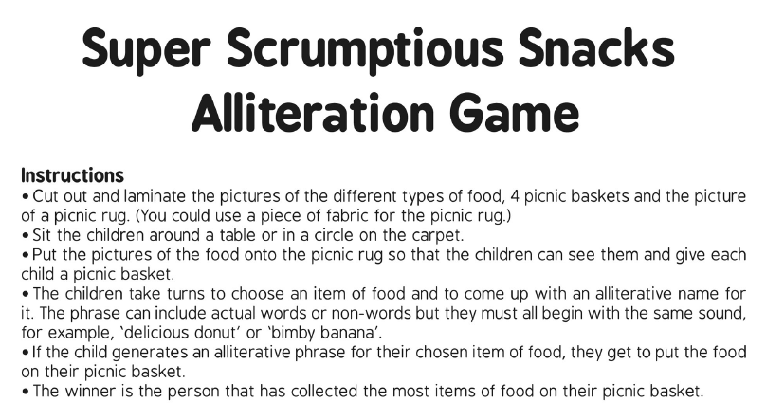

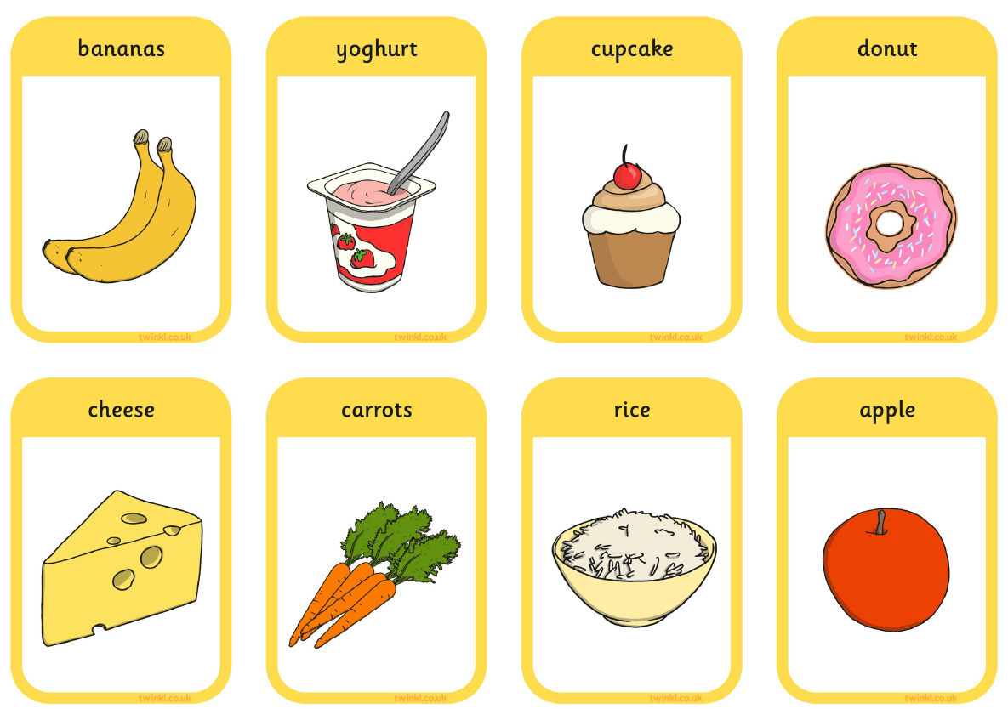
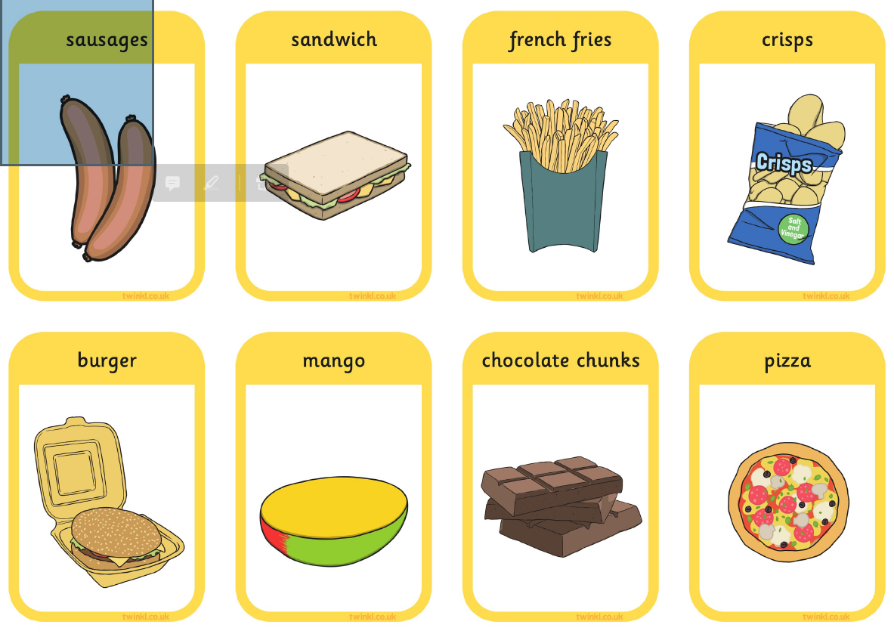
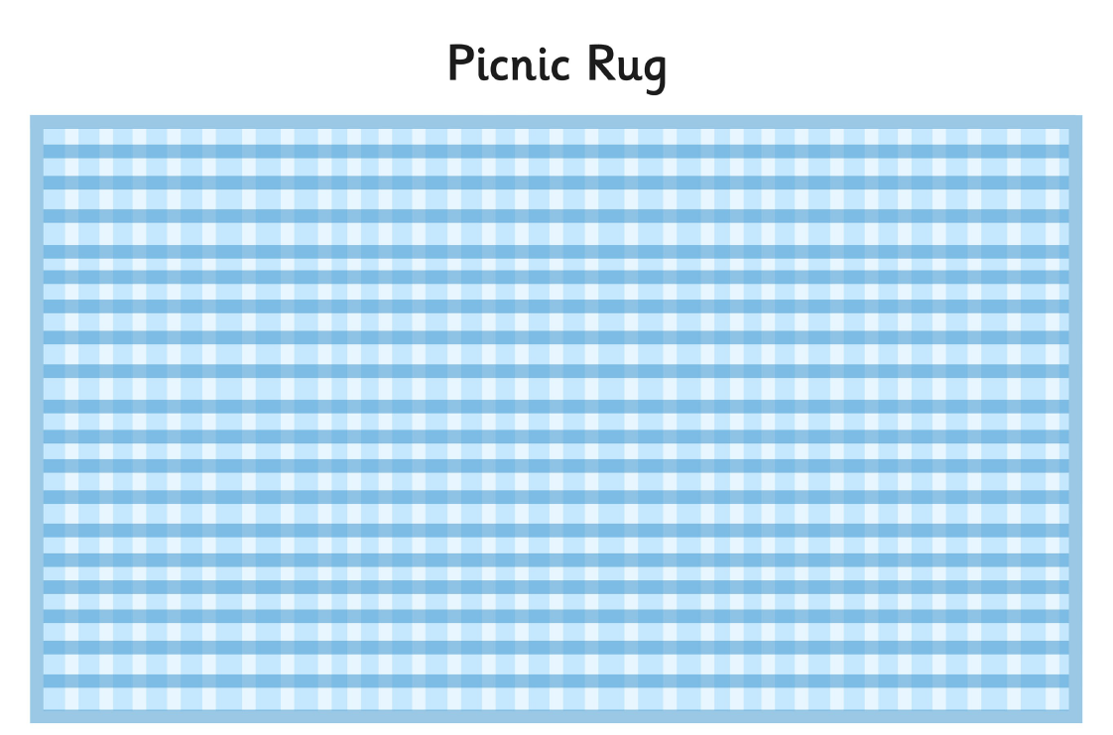

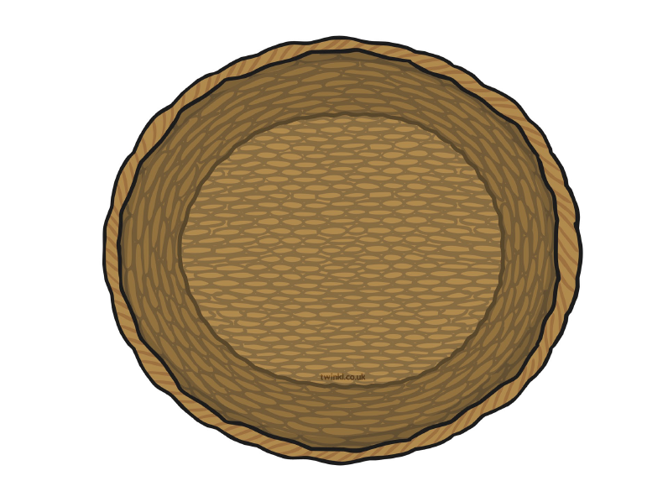

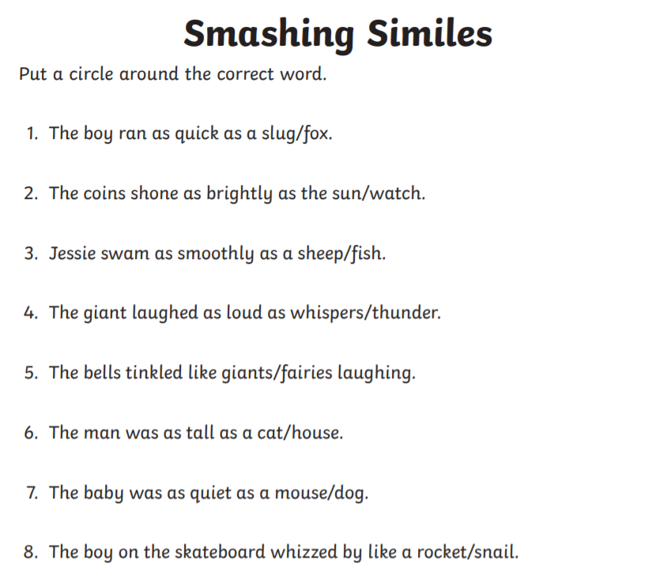

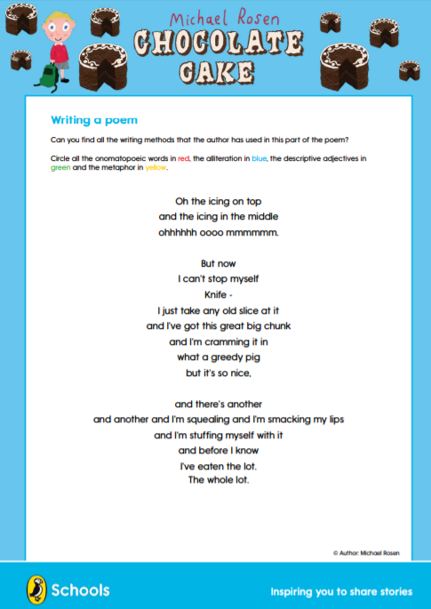

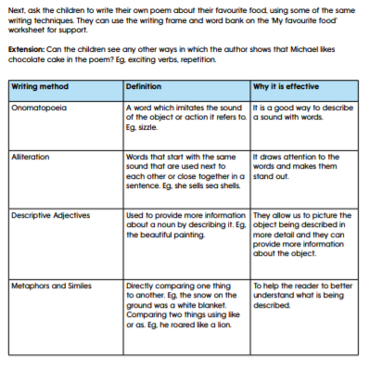
Writing your own poem
Time to write your own poem

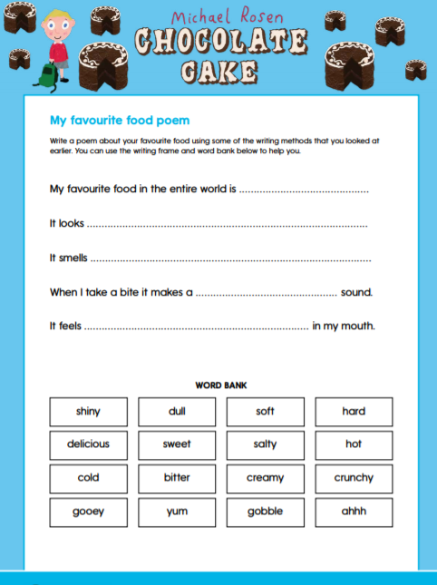
Writing your own poem

Once you have written your own poem. See if you can learn it by heart and practise reading it with volume, intonation and facial expressions. After several practises perhaps ask an adult to film it so you can watch yourself back. Maybe you can even send it in and share with us!

