Thursday 15th October 2020
The Leaf Man Due in 21.10.20
In her new work, Ehlert celebrates the astonishing variety and beauty of autumn leaves. The story line follows the journey of Leaf Man, who used to live in a pile of nearby leaves, but has now been caught by the wind and blown here and there. After all, A Leaf Man's got to go where the wind blows.
Use the link below to watch the story of Leaf Man. Pay particular attention to the objects. What are they made from?
https://www.youtube.com/watch?v=bqW-j3WV6g8

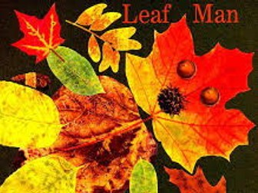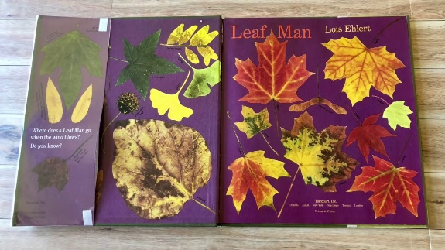

It was great to see so many of you embracing the autumnal walk activity using your senses to describe what you discovered. Our classroom display is looking amazing and that all because of your hard work. You should be extremely proud of what you managed to achieve!!
This week your challenge is to either:
- Create a new character to join Leaf Man on his adventure (could be a friend, mum, favourite toy) what would the character be made from or look like? What impact would they have on the story?

- Write your own story about Leaf Man or change part of the story. You may want to create a comic strip to show Leaf Man on his adventures! Adaptations of the story could be Leaf Man goes on holiday or Leaf Man’s day at school!

We will be having a show and tell Wednesday afternoon to share homework with the class so get creative!!

