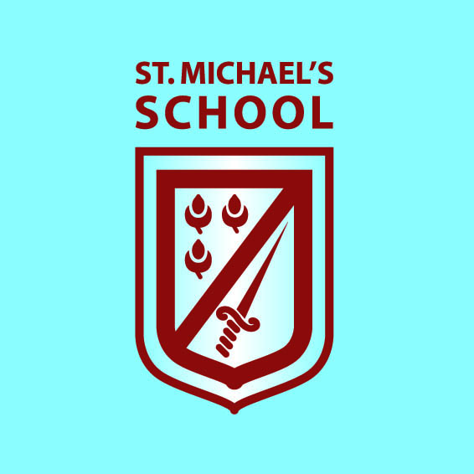
‘Learning together through love, friendship, forgiveness and faith.’

St Michael’s PE and Sport Grants 2017/18
In September 2017, the Government confirmed that the primary PE grant would double for the academic year 17/18 so that all schools will receive a lump sum of £16,000 and an additional payment of £10 per pupil. For St Michael’s this means that the sport’s funding received for the 17/18 year was £14,095
This additional funding has been used to develop our outdoor area in EYFS to increase physical development of our youngest children hoping that this will forge new learning behaviours and a healthy approach to PE. This area is also used by a local Nursery who have no on site access to outside green spaces.
The funding has also enabled us to install a much needed new and safer adventure playground. The playground was planned in consultation with the School Council and meets the physical needs of all the pupils across all the key stages.

Eligible Pupils 5 and over (Jan 2017) | TOTAL  PE & Sport Grant  2017 to 2018 (£) | 57%  For payment Nov 2017 (£) | 43%  For payment in May 2018  (£)
179 | £16,000 lump sum +£10 per pupil = | £10,378 | £7,412

Term | Project | Cost to School | School Costs  %
Autumn | EYFS Outdoor Area | £16,939 | 40.96%
Spring Term | Adventure Playground | £17, 208 | 62.2%

